EVIDENCE OF MICROBIALIZATION INDUCED BY CORAL-ALGAL PHASE SHIFTS ON
CORAL REEFS OF MO’OREA, FRENCH POLYNESIA

A THESIS SUBMITTED TO THE GRADUATE DIVISION OF THE UNIVERSITY OF HAWAI‘I AT MĀNOA IN PARTIAL FULFILLMENT OF THE REQUIREMENTS FOR THE DEGREE OF

MASTER OF SCIENCE IN
OCEANOGRAPHY

AUGUST 2026

By
Keanu G. Rochette-Yu Tsuen

Thesis Committee:
Craig Nelson, Chairperson
Nyssa Silbiger Nicholas Hawco
Keywords: Microbialization, Phase Shifts, Microbial Communities, Biogeochemistry

©Keanu G. Rochette-Yu Tsuen 2026

Acknowledgements
- Committee members : Craig nelson; Nyssa silbiger, Nick hawco - Rayna mcclinktock - Laurel Diaz - Nelson Lab members
  - Gump Station staff
  - Oceanography: Blake Stoner-Osborne, Kristen Connor
  - Mom and Vincent, Tatie Vito - MGAL and SLAB (Danielle?)
  - SKM Dorm people

Dedication
UPCOMING

Abstract
Coral reefs are highly productive ecosystems, despite occurring in oligotrophic tropical oceans, thanks to bacterioplankton which play a critical role in recycling dissolved compounds. Reefs worldwide exhibit trends of declining coral cover with concomitant increases in macroalgae. More specifically, decadal data from the Moorea Coral Reef Long Term Ecological Research program show that Moorean reefs have suffered significant structural damages from past predator outbreaks (Acanthaster planci), cyclonic events, marine heatwaves, and ongoing anthropogenic impacts resulting in phase shifts from coral to macroalgal dominance. In this project, we seek to test the microbialization hypothesis, wherein phase shifts disrupt bacterioplankton recycling, leading to ineﬀicient organic matter metabolism and furthering coral decline. We hypothesized that an enrichment in macroalgae in benthic communities will alter seawater chemistry and organic matter flux with indirect effects on the composition and abundance of microbial communities consistent with microbialization. Mesocosm experiments simulated pre-disturbance (coral-enriched), post-cyclonic (crustose coralline algae-enriched), and post-marine heatwave (macroalgae-enriched) reefs to assess the effects of benthic communities on compositional dynamics of microbial communities and dissolved organic matter. Organic matter quantification was done via fluorescence spectroscopy and catalytic oxidation, while microbial community analysis was done using flow cytometry with amplicon next generation DNA sequencing. The results of this project will enhance our understanding of the interactions between bacterioplankton communities and coral reef benthic assemblages, with implications for carbon fixation and remineralization processes in the oligotrophic ecosystems of the South Pacific.

Table of contents

Acknowledgements i

Dedication ii
Abstract iii
List of Figures v
List of Tables vi
- Introduction 1
  - Ecological Phase Shifts in Coral Reefs Worldwide . . . . . . . . . . . . . . . 1
  - Effects of Organic Exudation of Benthic Primary Producers on Microbial Carbon Processing . . . . . . . . . . . . . . . . . . . . . . . . . . . . . . . . 2
  - Exudations Alter Microbial Community Structure . . . . . . . . . . . . . . 2
  - Mo’orea Coral Reefs: a Case Study of the Effects of Benthic Community Alteration on Coral Reef Biogeochemistry . . . . . . . . . . . . . . . . . . . 3
  - Project Objectives . . . . . . . . . . . . . . . . . . . . . . . . . . . . . . . . 4
- Methods and Materials 6
  - Site Description Overview . . . . . . . . . . . . . . . . . . . . . . . . . . . . 6
  - Benthic Organism Collection for Mesocosm Communities . . . . . . . . . . 7
  - Mesocosm Experiment set up . . . . . . . . . . . . . . . . . . . . . . . . . . 7
  - Water sample collection . . . . . . . . . . . . . . . . . . . . . . . . . . . . . 8
  - Subsample collection and Laboratory analysis . . . . . . . . . . . . . . . . . 8
    - Dissolved Organic Carbon (DOC) . . . . . . . . . . . . . . . . . . . 8
    - Fluorescent Dissolved Organic Matter (fDOM) and Nutrients 10
    - Chlorophyll-a 11
    - Cell Abundance via Flow Cytometry 11
    - Bacterial Community Structure 12
  - Statistical Analysis 13
- Results 15
  - Nutrients and chlorophyll a 15
  - Organic Matter Exudation Rates in Mixed Benthic Communities 16
  - Bacterial Abundance and Chlorophyll-a 17
  - Changes in Microbial Community Structure Associated with Mixed Benthic Community Exudation 19
- Discussion 22
  - Benthic community composition drives treatment-associated patterns of or-ganic exudation and bacterial community structure 22
  - Organic exudation and composition is driven by benthic community assem-blages 22
  - Composition of organic exudates driven microbial community structure 23
- Conclusion 25
References 26
- Supplemental Material 32
  - Simple Linear Regression between Nutrients, Chlorophyll-a and Organic Mat-
ter vs. Flow Rate 32
  - Summary of Treatment, Time and Treatment-Time Interaction on Nutrient Measurements 32
  - Summary of Treatment, Time and Treatment-Time Interaction on Bacterial Families Relative Abundance 32

List of Figures

  - Mesocosm Experiment Setup. (Top) Mesocosms containing benthic communities enriched in coral [A], crustose coralline algae (CCA) [B] and macroalgae [C]. (Bottom) Disposition of the 16 mesocosms on flow-through water tables. . . . . . . . . . . . . . . . . . . . . . . . . . . . . . . . . . . . 9
  - Nutrient and Chlorophyll-a variation by treatment and sampling
time Variations in measured nutrient values are driven by the sampling time. 16
  - Exudation of Coble C Peak and HIX indices. fDOM exudation by treatment and across a diel cycle show increased production of Coble C and
HIX indices in algae-enriched communities 17
  - Cell abundance of heterotrophic bacteria and Synechococcus. Vio-lin plots of the abundance of bacterioplankton show increased heterotrophic bacteria cell count and decreased Synechococcus cell count in algae-enriched
communities across sampling time points. 19
  - NMDS plots of bacterial communities by treatment across four sampling time points. Each variable column shows time over 24h passing from left to right, starting at 12:00 until 06:00. Control, coral and CCA communities show similar enrichment patterns with bacterial communities enriched in oligotrophic bacteria. On the other hand, algae communities
become enriched in copiotrophic bacterial families. 20

  - Heatmap showing significant differences in bacterial families across treatment. These microbial families had significant ANOVA results for treatment and time effects with no interactions between treatment effects and time effects. Specifically, 13 families were significantly depleted in algae communities compared to the controls and 1 family was enriched in algae communities compared to the controls and this pattern was independent of
time. 21

List of Tables
  - Results of the Simple Linear Regressions between Nutrients and Chlorophyll-a vs. Flow Rate 33
  - Results of the Simple Linear Regressions between DOC and fDOM Indices vs. Flow Rate 34
  - ANOVA Results of the Nutrients Linear Mixed Effects Models 35
  - ANOVA Results of the Bacteria Families Linear Mixed Effects Models (A) 36
  - ANOVA Results of the Bacteria Families Linear Mixed Effects Models (B) 37
  - ANOVA Results of the Bacteria Families Linear Mixed Effects Models (C) 38
  - ANOVA Results of the Bacteria Families Linear Mixed Effects Models (D) 39

Introduction

Ecological Phase Shifts in Coral Reefs Worldwide
Evidence of ecological phase shifts can be observed worldwide as persistent environmental forcings shift coral reefs equilibrium state towards algal dominance. Over recent decades, coral reef decline has occurred steadily and extensively throughout the Indo-Pacific and the Caribbean (Bruno and Selig 2007; Done 1992). Phase shifts occur due to the combined effect of forcings which are detrimental to coral and favorable to algae. At a local-scale, proximity to human development is correlated with greater rates of coral decline (Barott et al. 2012). Chronic overfishing, specifically of herbivorous fish and invertebrates, reduces grazing pres-sure and thus contributes to the proliferation of macroalgae in coral reefs (Burkepile and Hay 2006; J. Smith, Smith, and Hunter 2001; Hughes 1994). Additionally, nutrient inputs from sewage and agricultural run offs favor eutrophic conditions which promote macroalgae growth, and can lead to hypoxic conditions (Bahr, Jokiel, and Toonen 2015; Lesser 2021; McCook 1999; Jennifer Smith et al. 2006). Urban development and dredging result in sedimentation and increased turbidity which prevents feeding and photosynthesis in corals resulting in detrimental effects to their health (Adam et al. 2021; Bahr, Jokiel, and Toonen 2015; Jones, Fisher, and Bessell-Browne 2019).
Regionally, stochastic events can drive large scale coral mortality, providing open spaces for macroalgae to spread. Marine heat waves and El Niño events induced large-scale bleaching resulting in coral mortality, thus weakening space competition in favor of macroalgae (Palmer, Rodríguez Esquivel, and Parker 2025) . Hurricanes and severe storms have caused extensive damage to coral reef structures, clearing spaces for algae to thrive (Schmitt et al. 2019; Edmunds et al. 2025; Palmer, Rodríguez Esquivel, and Parker 2025). Persistent conditions favoring algal growth and coral decline have been exacerbated world-

wide by sustained anthropogenic carbon emissions, thus providing conditions that further favor macro-algal dominance and are consistent with ecological phase shifts. Changes in benthic community composition are hypothesized to affect water column biogeochemistry with potential implications on ecosystem productivity, health, and functions.

Effects of Organic Exudation of Benthic Primary Producers on Microbial Carbon Processing
Exudates of benthic primary producers influence microbial metabolism and microbially me-diated processes. Benthic primary production represents a source of dissolved organic matter (DOM) in the water column with greater dissolved organic carbon (DOC) fluxes associated with macroalgae (116 to 339.2 µmol/L) compared to corals (73.6 to 82.6 µmol/L) (Haas et al. 2011, 2013). In isolated communities, corals and macroalgal produce exometabolites that are compositionally different in chemical classes and stoichiometry (Wegley Kelly et al. 2022). DOM associated with macroalgal communities showed enrichment in labile carbohydrates (galactose and fucose), while coral exometabolites were enriched in aromatic amino acid molecules (Nelson et al. 2013; Quinlan et al. 2018). Algal exudates are rapidly consumed by heterotrophic microbes, resulting in greater growth rate, bacterial activity and abundance (Haas et al. 2011, 2016; Nelson et al. 2013; Quinlan et al. 2025). However, despite rapid carbon consumption, algal exudates are associated with reduced microbial growth eﬀiciency which limits carbon recycling through the microbial loop with repercussions on abundance and biodiversity of higher trophic consumers ( Nelson, Wegley Kelly, and Haas 2023; Silveira et al. 2015).

Exudations Alter Microbial Community Structure
The analysis of metagenomic taxonomy of the 16S rDNA gene reveals that water column bacterial communities are coupled with the benthic ecosystem via DOM exudation. In oligotrophic coral reefs, exudated dissolved organic matter (DOM) constitutes the base of microbial food chains and bacterioplankton plays a critical role in the remineralization of dissolved molecules (Nelson et al. 2013; Tanaka, Ogawa, and Miyajima 2011; Wild

et al. 2010). Evidence suggests that microbial community structure changes in response to exposure to DOM composition, quantity, and quality, with repercussions on species even-ness (Quinlan et al. 2018; Sparagon et al. 2024). Coral exudates have been associated with oligotrophic taxa, specifically, Alphaproteobacteria families (Erythrobacteraceae, Ko-rdiimanodaceae, Hyphomonadaceae) (Haas et al. 2016; Nelson et al. 2013). On the other hand, algal exudates had a greater association, copiotrophic taxa, e.g., Gammapro-teobacteria families (Enterobacteriaceae, Vibrionaceae, and Pasteurellaceae), Bacteroidetes (Cytophagaceae and Flavobacteriaceae) and other families such as Brucellaceae, some of which have a higher likelihood of carrying bacterial virulence factor genes (Haas et al. 2016). As a result, alteration to bacterial communities could impact microbially mediated carbon remineralization, nutrient recycling, and biomass transfer to higher trophic level, and fur-ther impact the ability of corals to persist in the ecosystem as they may face challenges with feeding, photosynthesizing, calcifying, and maintaining homeostasis (Morrow et al. 2012; Nelson, Wegley Kelly, and Haas 2023).

Mo’orea Coral Reefs: a Case Study of the Effects of Benthic Community Alteration on Coral Reef Biogeochemistry
Interactions between the coral reef benthos, carbon fluxes, and bacterioplankton remain poorly understood in mixed benthic communities. Previous studies either used mesocosm experiments with isolated benthic organisms to measure the organic exudation and microbial metabolism (Brocke et al. 2015; Haas et al. 2011; Nelson et al. 2013), or in-situ surveys to measure net organic matter release and microbial communities in the coral reef ecosystem (Comstock et al. 2022; Haas et al. 2016; Nelson et al. 2011). No mesocosm experiment has been conducted to study links between mixed benthic community assemblages, organic outputs, microbially mediated processes, and bacterial community structure in coral-algal phase shift conditions. The island of Mo’orea, French Polynesia, represents an ideal location to address the gap in knowledge regarding coral-algal phase shifts induced microbialization. Decadal benthic surveys from the Mo’orea Coral Reef Long

Term Ecological Research program (MCR LTER) have shown that reefs have exhibited a series of shifts in dominant benthic taxa with partial recoveries throughout its history. Long term surveys enabled the development of a well-informed hypothesis on the etiology of the coral-algal phase shifts occurring in Mo’orea: 2006 predator outbreaks of Acanthaster planci (Crown-of-Thorns seastar or taramea), 2011 cyclone Oli, and 2019 marine heatwave (Kayal et al. 2012; Schmitt et al. 2019) . Additionally near shore nutrient enrichment (John et al. 2025) and overfishing may facilitate macroalgae growth in their competition for space against corals (Adam et al. 2021; Schmitt et al. 2019). Understanding the implications of coral-algal phase-shifts in Moorean reefs would provide invaluable indights on the mechanistic onsets of microbialization, the magnitude of the biogeochemical changes, and the resilience of the ecosystem.

Project Objectives
In this project, we sought to understand the effects of the enrichment of selected primary producer taxa in mixed benthic assemblages on organic exudation and composition. We also aimed to assess the effects of exudates on bacterioplankton abundance and community structure. We hypothesized that DOC production would be significantly greater in communities enriched in macroalgae with compositionally distinct DOM outputs. Consistent with the microbialization hypothesis, we expected to observe distinct bacterial communities associated with algal enrichment, with greater abundance of copiotrophic bacterial families. Additionally, inorganic nutrients (ammonia, nitrate, and phosphate) are hypothesized to be more depleted in algal communities, especially during the daytime, due to photosynthesis. To do so, we designed a large scale flow-through mesocosm experiment tracking dynamics of organic matter and microbial communities among reef assemblages representative of benthic community types found over the past two decades on the North Shore of Mo’orea, i.e., coral-enriched communities, and post-disturbance reefs (enriched in crustose coralline algae (CCA), and enriched in macroalgae) to investigate coupled changes in organic exudations, bacterial abundance, and bacterial community structure. Results from this project will inform on the effects of mixed communities on organic exudation, carbon processing, and

microbial community dynamics with respect to the phase shift induced microbialization.

Methods and Materials

Site Description Overview
Mo’orea is a small volcanic high island (135 km2) located in the Society Islands of French Polynesia (17°30’S, 149°50’W), in the South Pacific. The island is surrounded by an extensive coral reef barrier, roughly 0.5 kilometer from shore, through which 12 reef passes allow seawater to flow between the lagoons and the open ocean. The inner side of the reef barrier represents a distinct shallow back reef habitat (about 3 m deep) where reef patches, sepa-rated by sand, coral rubble, and reef pavement, dominate the benthic habitat (Leichter et al. 2013). In this study, we aim to characterize the biogeochemical and bacterial community changes associated with altered benthic ecology. Using benthic cover time series from the LTER program, we identified three ecological phases: a coral-enriched pre-disturbance reef (2006), post-cyclonic crustose coralline algae (CCA)-enriched reef (2011), and a post-marine heatwave algae-enriched reef (2019). We experimentally recreated the 2006, 2011 and 2019 reef assemblages, representing 3 treatments, in mesocosms using coral fragments, CCA, algae, sand, and coral rubble from the back reef of Papetō’ai, Mo’orea. The 2-dimensional planar benthic cover of the mesocosms was determined based on the percent cover recorded in the LTER time series. In addition to our treatments, a seawater-only mesocosm was used as control. The mesocosms were randomly assigned to two flow-through seawater tables, each connected to an overhead supply line that provided seawater to individual mesocosms through separate tubing. Flow-through tables were located in a partially shaded mesocosm facility at the Gump Research Station. Despite overhead roofing, light exposure was spatially uneven, with increased afternoon irradiance on one side of the facility.

Benthic Organism Collection for Mesocosm Communities
Benthic organisms, especially corals, crustose coralline algae and macroalgae Turbinaria ornata were collected under permit # XXXXX in the back reef of the North shore of Mo’orea, in the Papetō’ai district (17°29’09.0”S, 149°52’42.6”W). Porites rus coral fragments, Turbinaria ornata, crustose coralline algae (CCA) (Porolithon onkodes and Hydrolithon sp.), coral rubble, and sand were collected on snorkel at 3 m depth. P. rus colonies (~15 cm in diameter, n = 24), Porolithon onkodes and Hydrolithon sp. were col-lected using a hammer and chisel. Whole T. ornata (~20 cm tall) was collected by hand at the substrate level (n= 52). Additionally, sand was collected using a hand trowel and buckle from the top 5 cm oxic layer of sediments. Samples were brought back in coolers to the Gump South Pacific Research station, located in Piha’ena, Mo’orea. The Gump Station is an American research station supported by the Long-Term Ecological Research (LTER) program, managed by the University of California, which provides the necessary facilities to conduct research in French Polynesia.

Mesocosm Experiment set up
Mesocosms were set up in 11.4-liter clear polycarbonate aquaria (27.62 cm x 27.62 cm x 20.32 cm) that were previously leached in DI-water for 24h. Two holes were drilled into the side of the aquaria, about 13 cm apart, fitted with PVC pipes and nozzles that were fixed with PVC cement. PVC valves on each water outlet allowed to measure and control the flow rate of the out-going water. Water flow rate was adjusted every five days by measuring the volume of water flowing out of the tank for a minute. Average outgoing flow rates of the aquaria were 5.86 ± 6.00 mL.s-1. Aquaria were placed in flow through water tables equipped with overhead pipes to supply seawater from Paopao Bay (Cook’s Bay). Mesocosms aimed to recreate benthic cover of the reefs of Moorea based on 2006, 2011 and 2019 LTER data. Coral-enriched aquaria represented a pre-disturbance state (44% coral, 34% rubble, 18% sand, 2% CCA, 2% Turbinaria). CCA-enriched tanks represented reefs post-Acanthaster planci outbreak and post-cyclonic disturbance (15% coral, 34% rubble, 25% sand, 25% CCA, 1% Turbinaria). Algae-enriched aquaria represented contemporary

conditions (5% coral, 55% rubble, 20% sand, 0% CCA, 20% Turbinaria) ( Figure 2.1 ). Additionally, seawater aquaria were used as control mesocosms; each treatment and control had four replicates distributed randomly on two flow-through water tables. Circulation pumps (600 L/H) were placed in each aquarium to ensure water circulation and avoid deoxygenation.

Water sample collection
Throughout this experiment, we aimed to establish a comprehensive biogeochemical profile of the coral reef communities when exposed to our treatments. Using acid washed 1L poly-carbonate bottles, we collected bulk water samples from the mesocosms from which various subsamples were subsequently partitioned. Each bottle was assigned to a specific mesocosm and only collected water from that aquarium. Bottles were triple rinsed with mesocosm wa-ter before bulk water collection. Water tables had an independent overhead central inflow pipe from which water lines were connected to supply water flow to the mesocosms. Water samples were also taken from the inflow pipes. Bulk water samples were filtered to measure dissolved organic carbon (DOC), fluorescent dissolved organic matter (fDOM) indices, nutrients (total nitrogen, nitrate, nitrite, ammonia, silicate and orthophosphate), water column chlorophyll-a, bacterial abundance, and bacterial community structure. Experiments took place during the Austral winter. Water samples were taken over 24-hours, from June 2, 2024, 12:00 to June 3, 2024, 06:00. A set of 8 DOC samples collected on the night of 02 June 2024 were extreme statistical outliers greater than 2 standard deviations (70 µM) above the experimental mean (140 µM; n= 72) and were excluded due to contamination; other parameters collected at these timepoints were not outliers in any other parameter.

Subsample collection and Laboratory analysis

Dissolved Organic Carbon (DOC)
Bulk water sample from the aquaria was filtered via a Golander DG 6-12 peristaltic pump appended with 0.7µm, 25mm diameter Sterlitech Type F syringe filters. Water lines were acid washed before filtration and were rinsed with mesocosm water before sample collection. Filtered water was stored in precombusted 24mL borosilicate vials, triple washed with fil-trate, and acidified with hydrochloric acid (HCl 10%), then stored in the dark. Samples were processed at the School of Ocean and Earth Science and Technology Laboratory for Analyt-ical Biogeochemistry (S-LAB), University of Hawai’i at Mānoa. DOC was measured using a Shimadzu TOC-L Combustion Analyzer (detection limit of 4µg/L) via high-temperature catalytic oxidation using methods from (Carlson et al. 2010).

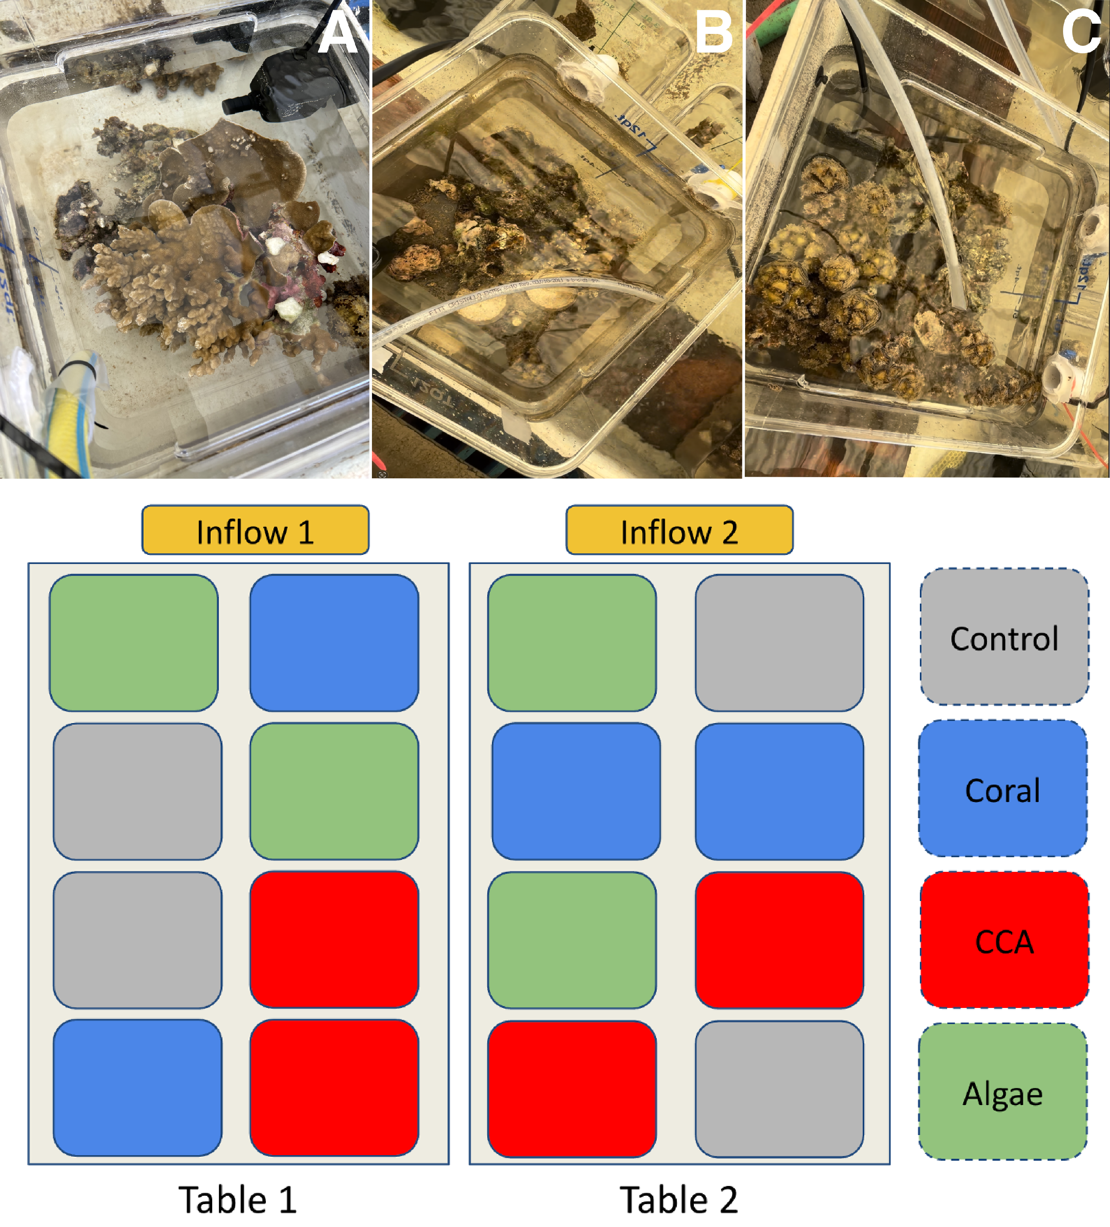

Figure 2.1: Mesocosm Experiment Setup. (Top) Mesocosms containing benthic commu-nities enriched in coral [A], crustose coralline algae (CCA) [B] and macroalgae [C]. (Bottom) Disposition of the 16 mesocosms on flow-through water tables.

Fluorescent Dissolved Organic Matter (fDOM) and Nutrients
Using the same pumping system, the Golander DG 6-12 peristaltic pump was aﬀixed with 0.22 µm Sterivex-GP pressure filters (Millipore Sigma). Filtered water for fDOM and nutrient measurement was collected in 50 mL falcon tubes, triple-rinsed with filtrate prior to sample collection, and stored at -40°C. Samples were thawed 12 hours prior to fDOM measurements to allow them to come to room temperature. 1 cm quartz cuvettes were triple washed with DI water and wiped dried with Kim wipes. 3 mL of sample water was aliquoted in the cuvette and placed in a Horiba Aqualog scanning fluorometer. The cuvettes were triple rinsed with DI water in between samples. Samples were measured in groups of 7 with a DI water blank measured in-between groups. Data processing was performed using methods and scripts from Nelson et al. (2015). Excitation-Emission matrices (EEMs) were generated using excitation values every 5nm from 240nm to 500nm, and emission values measured continuously via CCD ranging from 250 nm to 825nm integrated over 4 sec at each excitation increment. Inner filter correction was applied to account for fluorescence quenching by absorbance (Kothawala et al. 2013). Fluorescence values were divided by the integrated emission range of 381nm to 426nm at an excitation of 350 nm in averaged DI water blanks to scale the measurements to Raman Units (Lawaetz and Stedmon 2009). An average blank EEM was calculated from DIW blanks run before and after each set of samples and was then subtracted from each set of 7 sample EEMs. Lastly, informative biogeochemical indices were calculated, such as, UV-Humics (Coble A), Visible-Humics (Coble C peak), and tryptophan-like (Coble T) (Coble 1996), fulvic acid (FI) (McKnight et al. 2001), and humic indices (BIX and HIX) (Huguet et al. 2009). After the

fDOM measurements, water samples were returned to the freezer for storage at -40°C before being used for nutrient measurement. Nitrate and nitrite (detection limit 0.006 µmol/L), orthophosphate (detection limit 0.012 µmol/L), silicate (detection limit: 0.116 µmol/L), and ammonia (detection limit 0.013 µmol/L) were measured with UV detection using the SEAL AA500 nutrient analyzer and following methods from (Kealoha et al. 2025).

Chlorophyll-a
The peristaltic pump was fitted with 0.45 µm HAWP nitrocellulose filters (MF-Millipore) and 250 mL sample water was filtered. The filters were frozen in aluminum foil at -40°C in the field lab, then stored -80°C for long term storage at the University of Hawai’i. The chlorophyll was extracted from the thawed filters by dissolving the filters in 5mL of 90% acetone for 6-8h in borosilicate vials. During the dissolution period, the capped vials were stored in the freezer. Samples were allowed to warm to room temperature 30 min before measurements. Chlorophyll-a fluorescence was measured using the Turner Design 10 AU fluorometer. Acetone solutions were loaded in the fluorometer to measure fluorescence at 680 nm. Final chlorophyll-a concentrations were calculated using the calibration curve of the SLAB which accounts for the filtrate and solvent volumes.

Cell Abundance via Flow Cytometry
1 mL of mesocosm seawater was sampled using a pipette with disposable tips and fixed with paraformaldehyde for a final concentration of 0.5% v/v and kept at room temperature until stored in cryovials at -80°C at the University of Hawai’i for long term storage. Samples were processed at the Biological Electron Microscope Facility (University of Hawai’i at Mānoa) using a Beckman-Coulter CytoFLEX S flow cytometer. Once thawed and brought to room temperature, 275µL samples were aliquoted to polystyrene 96-well U-bottom plates and stained with 7µL of Hoescht 34580 dye (40µg/µL) for a final concentration of 1µg/µL. Additionally, distilled water blanks (stained and unstained) were added to each plate. Samples were kept in the dark to stain for 30 min prior to being analyzed in the flow cytometer as per Selph (2021). Samples were drawn from each well at a rate of 60µL/min for 75 seconds, excluding the events of the first 15 sec to avoid cross-contaminations between wells.

Cell count was determined via hierarchical gating which separated events by size, DNA stain, and pigment-associated autofluorescence. The first gating separated the events in “low” and “high” chlorophyll content. Background events were determined by comparing bacterial counts in samples and blanks, and then removed from the sample events. Low-chlorophyll events were classified as heterotrophic bacteria while high-chlorophyll events were further divided by forward scatter. Large events were categorized as pico-eukaryotes while smaller events were labeled as picocyanobacteria. Cyanobacteria were sorted by phycoerythrin (PE) content with high PE events corresponding to Synechococcus sp., and low PE events were labeled as Prochlorococcus sp. Cell density (gated events per µL) was calculated by standardizing the event counts to the volume processed (60 µL).

Bacterial Community Structure
Sterivex filters used to collect nutrient and fDOM samples were frozen dry at -40°C in the field laboratory, then subsequently returned to the University of Hawai i and stored long term at -80°C. The 0.22 µm polyethersulfone filters were retrieved aseptically from the casing and placed in bead tubes (MP Biomedicals FastDNA™ Garnet Matrix). Samples were sent to the University of Hawai’i Microbial Genomics and Analytical Laboratory (MGAL) for DNA extraction using a Machery-Nagel NucleoMag microbiome kit on a ThermoFisher KingFisher Flex system. The V4 region of the 16S rRNA gene amplification following protocols from the Earth Microbiome Project (Caporaso et al. 2018) using forward-indexed primers 515F-Parada (5’-GTGYCAGCMGCCGCGGTAA-3’) and 806R-Apprill (5’-GACTACNVGGGTWTCTAAT-3’) (Walters et al. 2016). Minor modifications to the protocols were made such that triplicate reactions were not pooled and 1µL of ge-nomic template was used for amplification. The SequelPrep kit (Thermo Fisher Scientific) was used to clean and normalize the amplicons to equimolar concentrations. Samples were then pooled and sequenced using the Illumina MiSeq platform (600 cycle V3 chemistry). Sequences were demultiplexed using a probabilistic script; microbiome profiling was executed through the MetaFlow|mics pipeline (Arisdakessian, Cleveland, and Belcaid 2020) using settings from Jani et al. (2021). Sequences were assembled, denoised and trimmed using DADA2 and aligned with mothur to the Silva(v132) global SSU rRNA alignment database

(Callahan et al. 2016; Schloss et al. 2009; Yilmaz et al. 2014). Bayesian consensus classified the sequences (70% confidence) to the genus level, and clustered into 97% sequence identity operational taxonomic units (OTU) using VSEARCH (Rognes et al. 2016; Wang et al. 2007). Then OTUs were refined to reduce intragenomic taxonomic splitting errors using LULU (Frøslev et al. 2017). Sequences that could not be classified at the “Domain” level as well as Mitochondrial and chloroplast 16S sequences were discarded. The sequencing depth was then standardized to 10,000 random reads per sample. Bioinformatics data was processed on the C-MAIKI gateway at the University of Hawai i at Mānoa by the Center for Microbial Oceanography: Research and Education (Cleveland et al. 2022). After data processing, OTU that were not greater than 0.1% abundance in at least one sample were filtered out of the data set.

Statistical Analysis
To test the hypothesis that algal communities change DOC production, DOM composition, nutrient consumption, and bacterial abundance compared to the control, we ran linear mixed effects models with DOC, DOM, nutrient measurements and bacterial abundance as our dependent variables. Data processing and statistical analysis were performed using R (version 4.5.2) and RStudio (Version 2026.04.0+526, Posit Software, Boston, MA) (RStudio Team, 2025). For each variable, values that were outside of the x2 ranges were identified as outliers. Biogeochemical variables varied highly throughout the experiment period such that aquaria measurements were dependent on measured inflow values. The biogeochemical measurements were relativized to the average value of the inflow at the time of sampling, i.e., for each variable, values measured at each inflow table were averaged first, then aquaria measurements were relativized by subtracting the averaged inflow value from the aquarium measurements. Linear mixed-effect models were run using relativized data as a dependent variable, treatments of control, coral, CCA, and algae as independent variables with a sample time interaction term, and aquaria ID number as a random effects variable to account for repeated measures. Simple linear regression of relativized concentration against log-transformed flow rate showed no significant flow rate effects on any variables (Supple-

mental Table 6.1). As such, log-transformed flow rates were added as a predictor in linear mixed-effect models for robust statistical modeling. Analysis of variance (ANOVA) allowed to understand variations between treatment groups. For models that had a significant effect, we used a Dunnett’s post hoc test to determine contrasts. Additionally, we also calculated contrast effect size (Cohen’s D, i.e., d) to evaluate the magnitude of the difference between seawater control and treatments. Figures were created using the ggplot2 and patchwork packages (Pedersen 2025; Wickham 2016). To understand changes in bacterial community composition, we ran a PERMANOVA model using adonis2() from the package vegan (Oksanen et al., 2026). We used the Unifrac distance matrix generated from the MetaFlow|mics pipeline with treatments, sampling time point and the log10-transformed flow rate as model predictors. We also accounted for treatment-time interactions, and repeated measurements using the aquaria ID number in the “strata” argument. Bacterial community changes were visualized in NMDS plots calculated from the vegan package.

Results

Nutrients and chlorophyll a
Relativized concentrations of orthophosphate, nitrate, ammonia, and silica were measured to assess the net nutrient uptake of mixed communities and across photosynthetically active hours of the day ( Figure 3.1). Nutrients did not exhibit significant differences among treatments. Significantly differed across sampling time points (PO4: F= 19.48, p <0.05; SiO2: F=11.92, p <0.05; NH3: F=77.66, p <0.05; NO3: F = 10.37, p <0.05; Supplemental Table 6.3). Post-hoc Dunnett’s contrasts show that seawater control exhibited a significant difference in nutrient concentration at 06:00 compared to 12:00 sample time (Dunnett’s contrast : p<0.05). Results suggest that net nutrient dynamics were independent of benthic community composition but dependent on the time of sampling with a greater net nutrient uptake in the control mesocosms at 06:00.

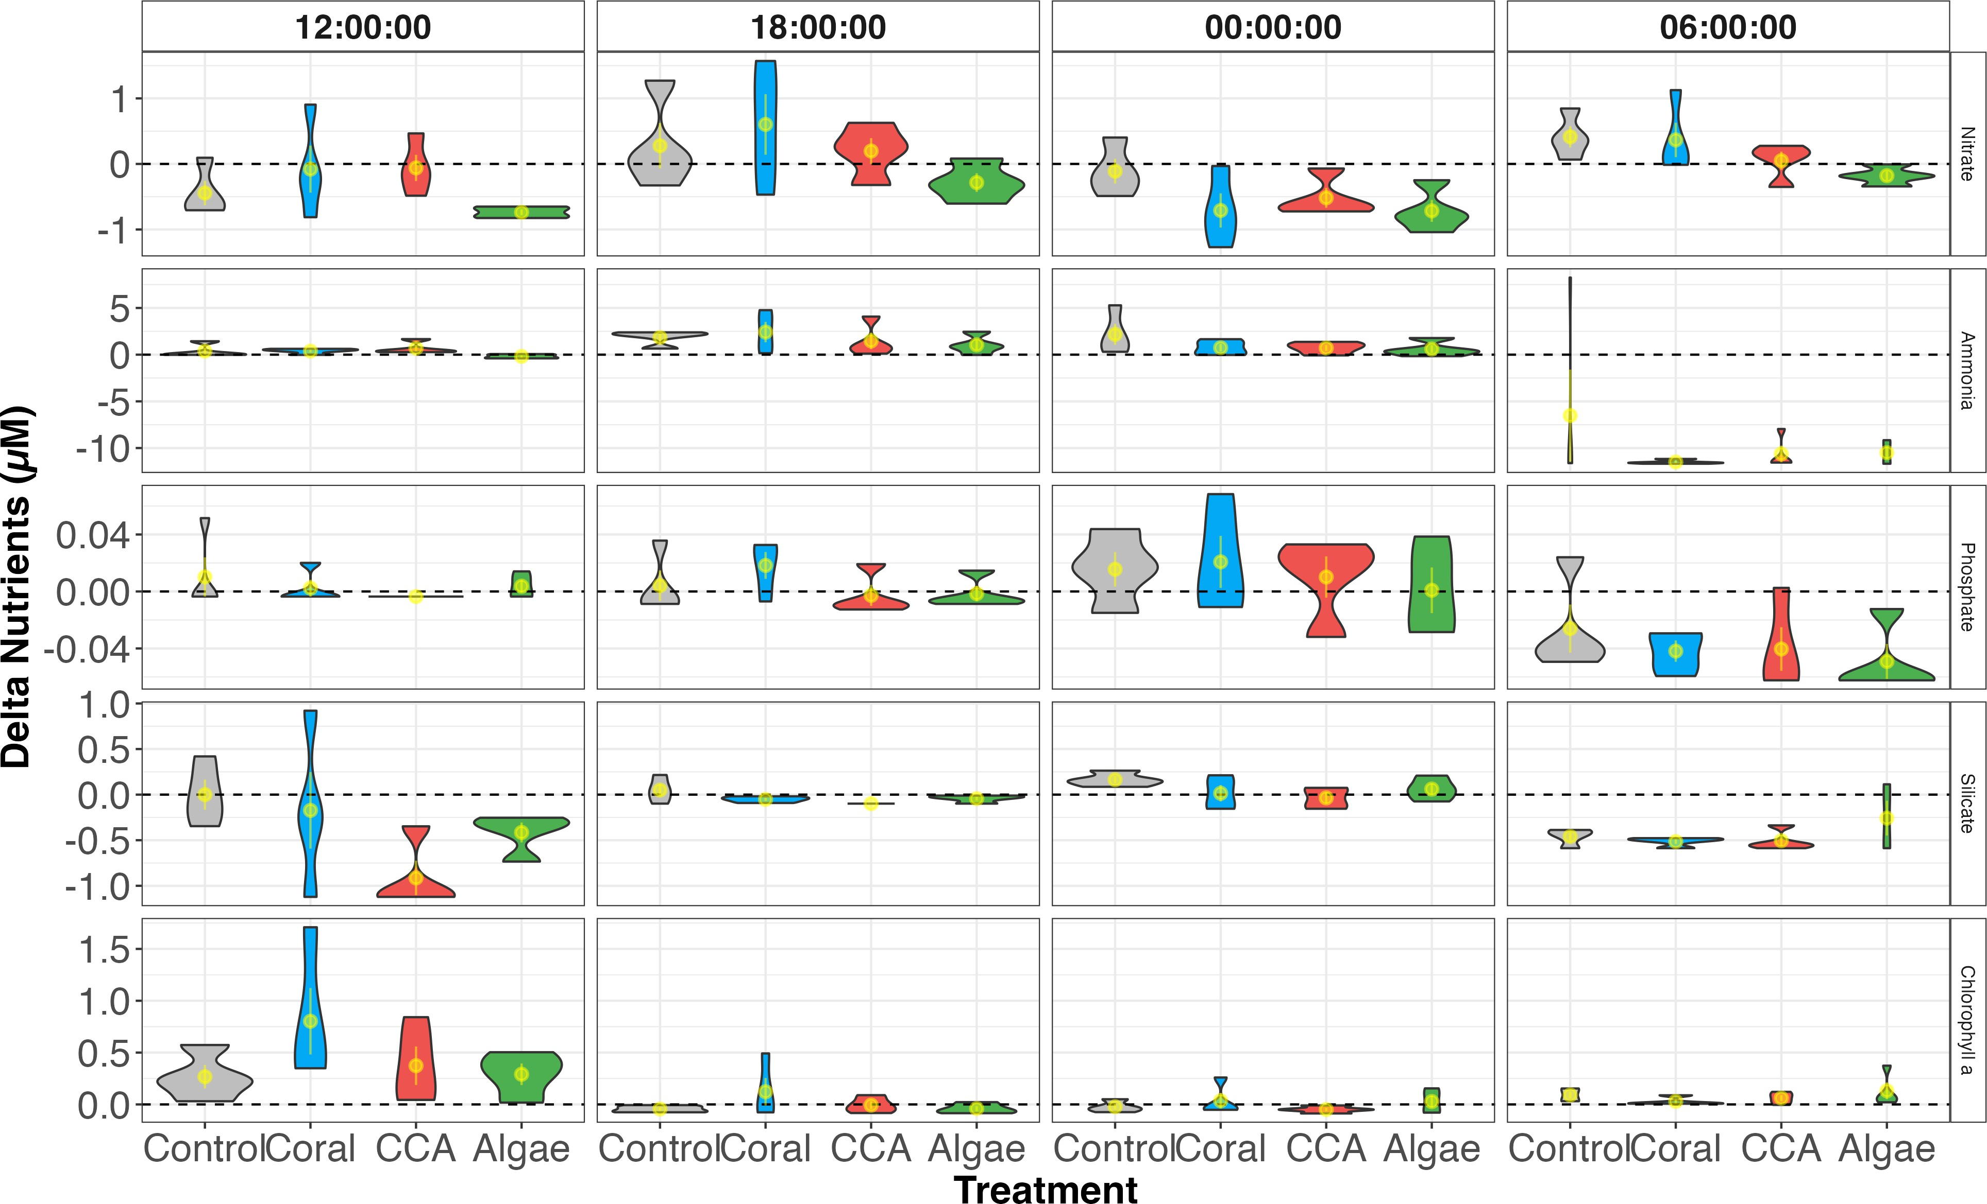
Figure 3.1: Nutrient and Chlorophyll-a variation by treatment and sampling time
Variations in measured nutrient values are driven by the sampling time.

Organic Matter Exudation Rates in Mixed Benthic Communities
Following the 24h incubation period, bulk DOC and fDOM-derived indices were measured to assess whether the organic exudation varied among mixed reef assemblages and across the diel sampling period. Linear mixed effect models showed contrasting patterns between DOC and fDOM components. Bulk DOC concentrations did not differ significantly among community treatments (F = 0.78, df = 3, p = 0.53). In contrast, humic indices (Coble C peak fluorescence and HIX) showed significant treatment effects (Coble C: F= 5.04, df= 3, p<0.05; HIX: F= 3.84, df= 3, p<0.05). Dunnett’s contrasts and pairwise contrasts against seawater controls showed that algae-enriched communities exhibited significantly greater Coble C production (Coble C: d = 1.31, p < 0.05). HIX exhibited significant pairwise contrast effect size, however, treatment vs. seawater control did not reach significance after multiplicity correction (HIX: d = 0.88, coral: p = 0.78, CCA: p = 0.75, algae: p = 0.12). Time of sampling did not significantly affect the treatment effect in either index (Coble C: F=0.87, df = 9, p = 0.56; HIX: F =0.78, df = 9, p = 0.63). Taken together, results show that bulk DOC did not change significantly across mixed reef communities, however, algae-enriched communities exhibited a preferential release of humic-like exudates compared to the seawater control, independently of sampling time.

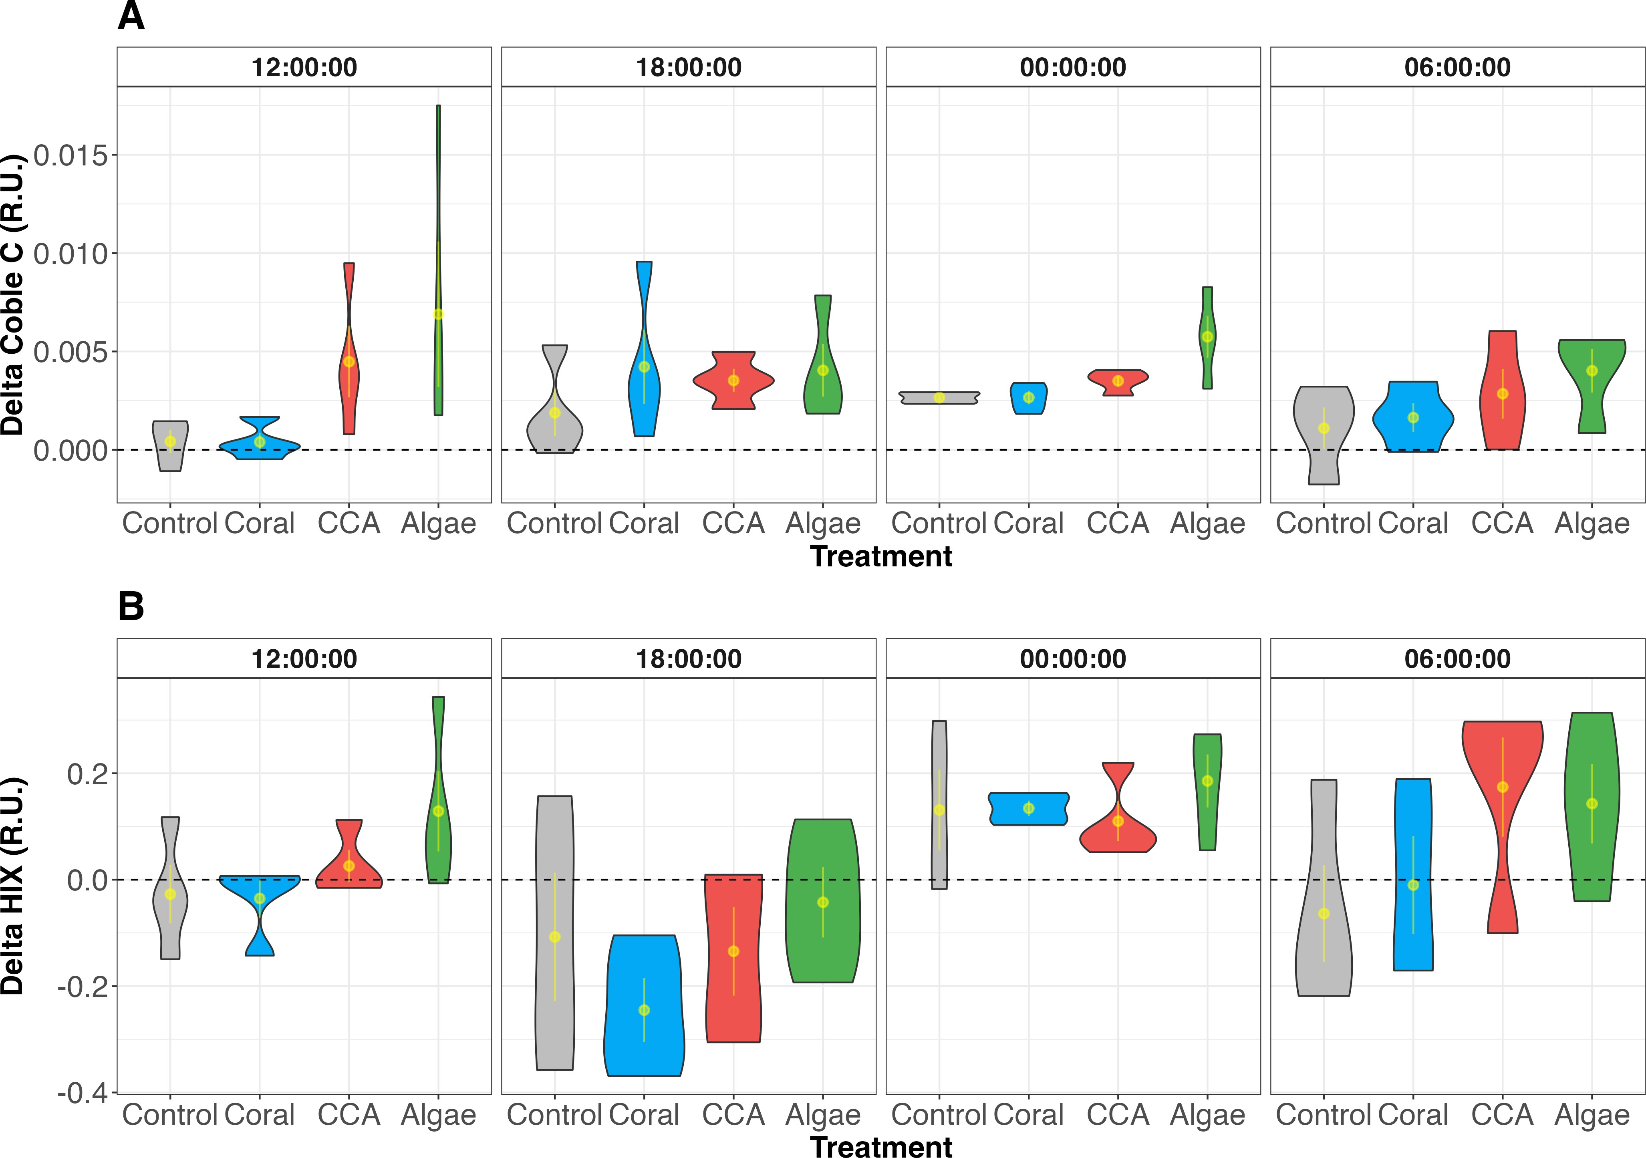
Figure 3.2: Exudation of Coble C Peak and HIX indices. fDOM exudation by treat-ment and across a diel cycle show increased production of Coble C and HIX indices in algae-enriched communities

Bacterial Abundance and Chlorophyll-a
Bacterial cell count was measured to assess the effects of mixed reef community exudates on bacterial abundance across a diel sampling period. Heterotrophic bacteria and Synechococcus spp. exhibited significant treatment effects (Heterotrophic bacteria: F= 8.05, df
= 3, p <0.05; Synechococcus : F= 9.84, df = 3, p <0.05). Synechococcus abundance varied

significantly over diel sampling time points (F= 13.19, df = 3, p<0.05) which was reflected in the measurement of water column chlorophyll-a (F= 15.7, df = 3, p<0.05). Heterotrophic bacteria, on the other hand, did not exhibit a significant sampling time effect (F= 0.08, df
= 3, p = 0.97). There was no significant time interaction with observed treatment effects (heterotrophic bacteria: F= 0.88, df=9, p= 0.55; Synechococcus: F= 1.94, df = 9, p= 0.77). Dunnett’s post hoc contrasts highlighted a significant depletion of Synechococcus in CCA-enriched communities compared to controls (p<0.05). Pairwise contrast effect size against seawater control showed large Synechococcus depletion in all treatments (Coral: d
= -1.71, CCA: d= -3.61, Algae: d= -1.94), though these did not reach statistical significance after multiplicity correction for coral and algae treatments. Dunnett’s post hoc contrast showed no significant differences between control and treatments in heterotrophic bacteria abundance despite showing large depletion in CCA mesocosms (d = -1.44) and large enrichment patterns in algae-enriched communities (d = 1.23) in the pairwise contrast effect size. Collectively, results suggest that mixed reef communities reduce Synechococcus abundance especially in CCA-enriched communities. Heterotrophic bacteria exhibited op-posing patterns depending on benthic community composition with large depletion effects in CCA-enriched communities and enrichment in algae-dominated communities, though neither reached statistical significance after multiplicity correction.

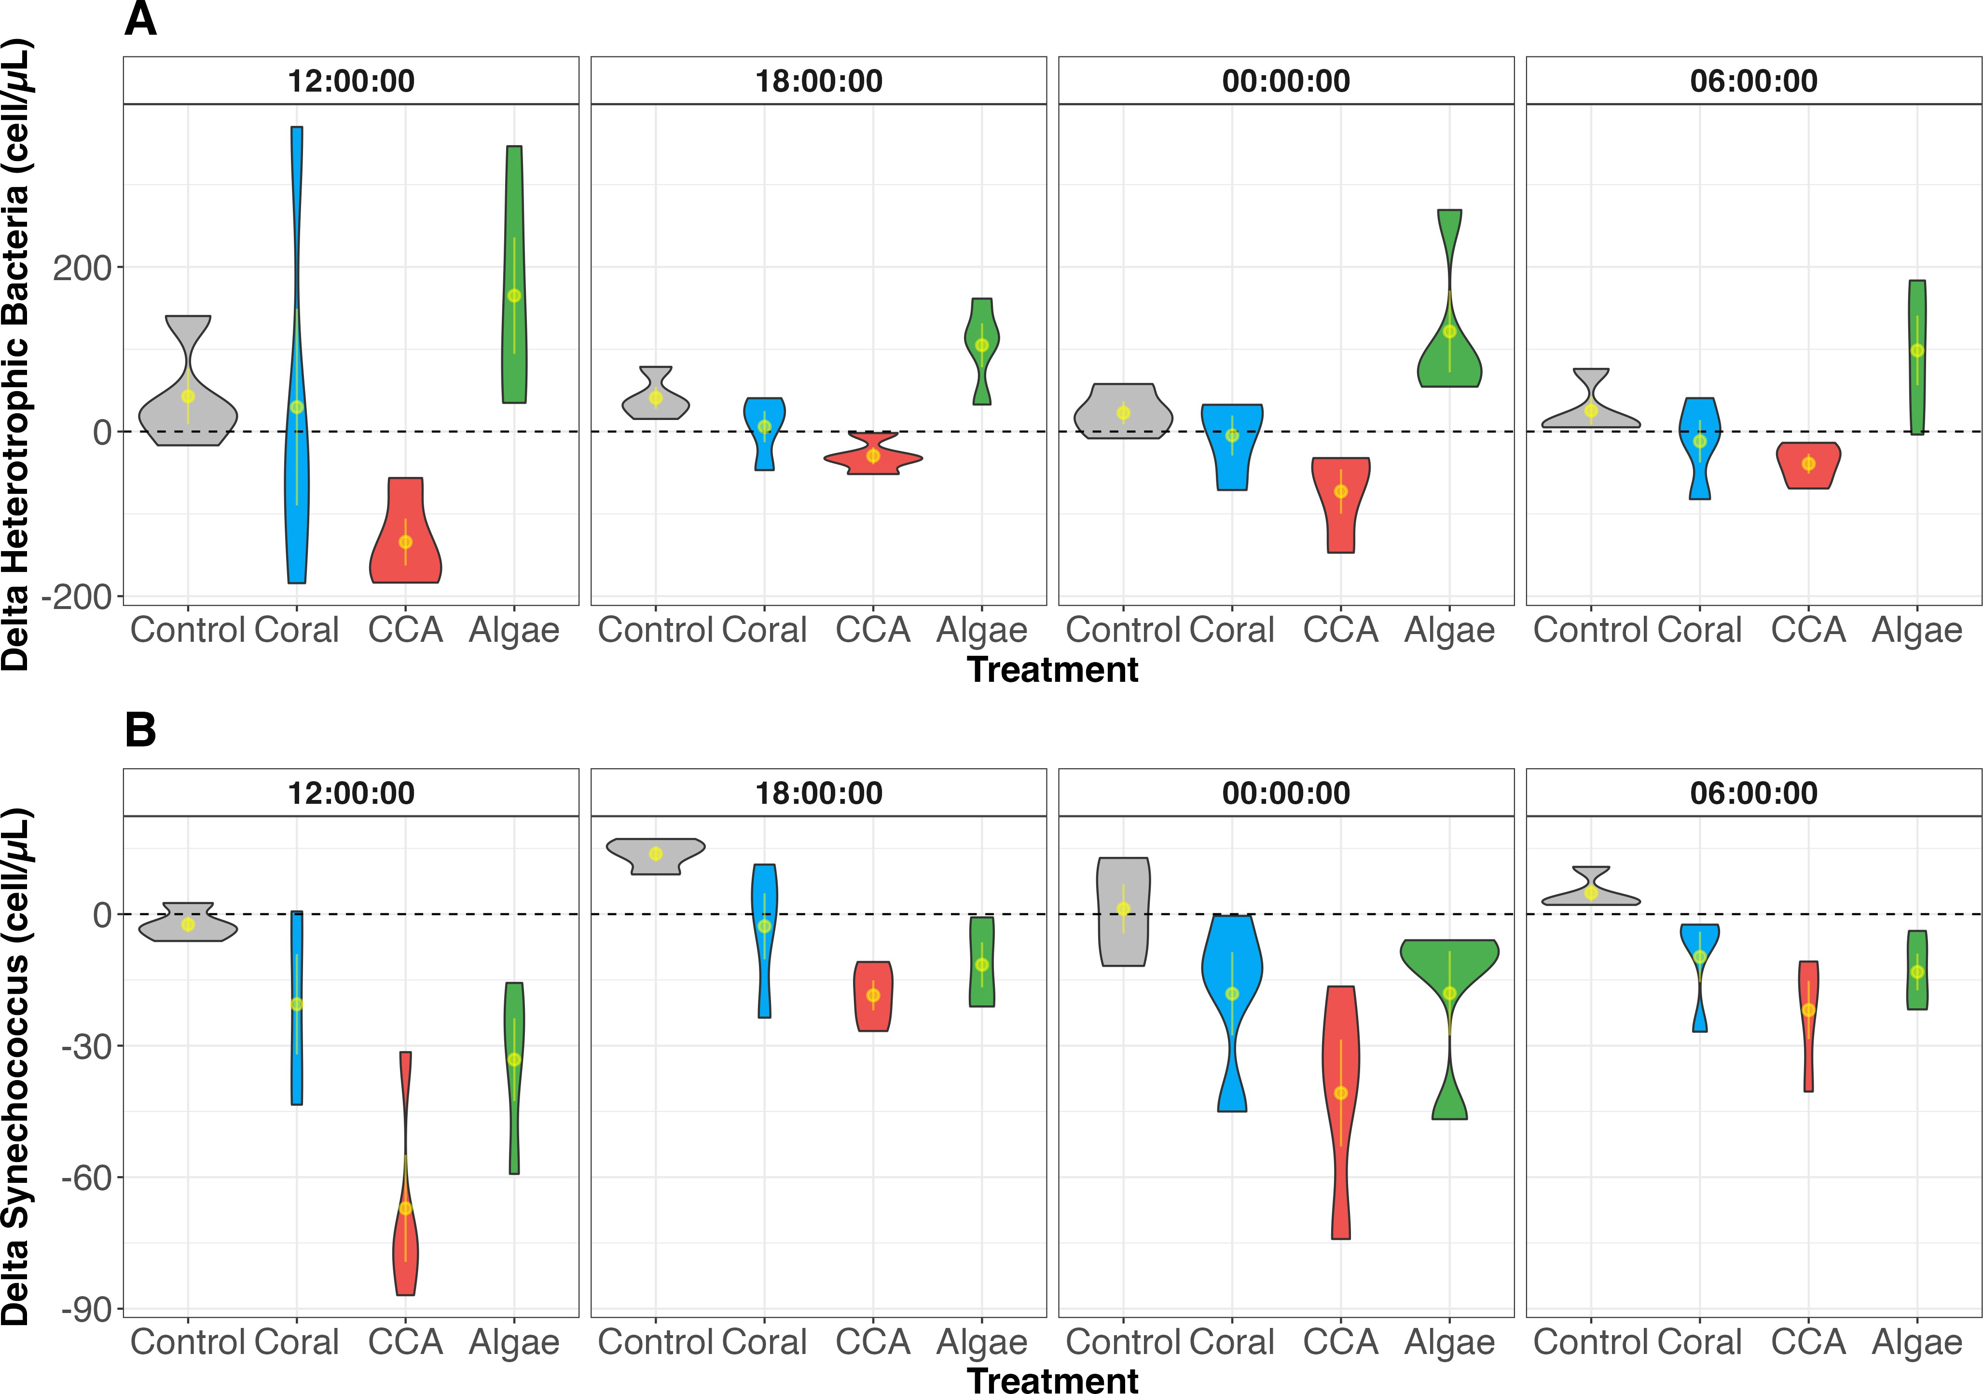

Figure 3.3: Cell abundance of heterotrophic bacteria and Synechococcus. Violin plots of the abundance of bacterioplankton show increased heterotrophic bacte-ria cell count and decreased Synechococcus cell count in algae-enriched commu-nities across sampling time points.

Changes in Microbial Community Structure Associated with Mixed Benthic Community Exudation
Microbial DNA was sampled over 24h to assess whether mixed benthic assemblages, particularly algae-enriched communities, would drive compositional divergence in bacterial communities relative to the seawater control. Non-metric multidimensional scaling (NMDS) plots from weighted UniFrac distances show microbial communities associated with algae-enriched communities were visually separated from other treatment groups (NMDS stress
= 0.123) ( Figure 3.4). PERMANOVA showed significant variation among treatments (F= 3.73, df= 3, R2 = 0.13, p= 0.001) with significant pairwise PERMANOVA, adjusted with Benjamini-Hochberg method, between the algae communities and seawater control (F = 5.24, df = 1, R2 = 0.15, p<0.05) ( Figure 3.4). Microbial communities changed throughout the duration of the experiment as demonstrated by the significant effect of the sampling time (F= 5.06, df= 3, R2 = 0.17, p<0.05). PERMANOVA at individual time points showed that community structures have become increasingly dissimilar over the course of the experiment

with no significant differences at the start (12:00: F= 1.04, df= 3, R2 = 0.20, p= 0.397) and significant differences at the end (06:00: F= 5.73, df= 3, R2 = 0.58, p<0.05).

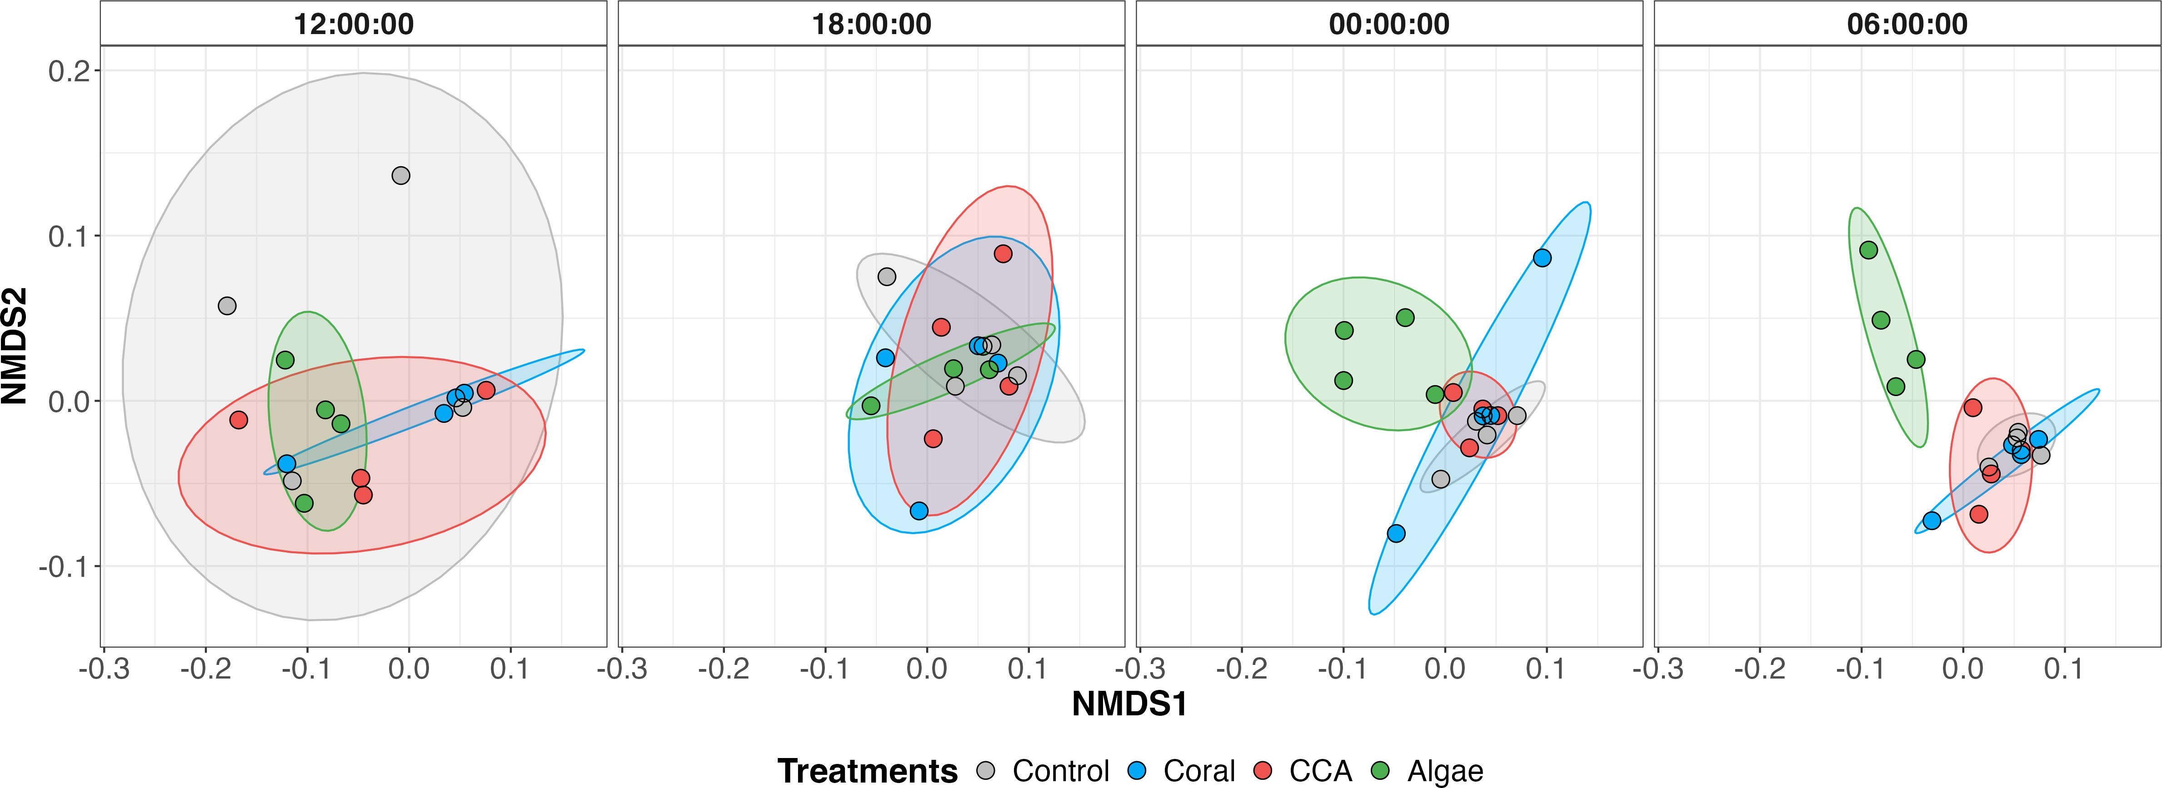
Figure 3.4: NMDS plots of bacterial communities by treatment across four sam-pling time points. Each variable column shows time over 24h passing from left to right, starting at 12:00 until 06:00. Control, coral and CCA communities show similar enrichment patterns with bacterial communities enriched in oligotrophic bacteria. On the other hand, algae communities become enriched in copiotrophic bacterial families.

Linear mixed-effects models identified bacterial families whose abundances significantly changed over our 24h sampling period. Through this experiment, 17 families showed significant treatment effects. Among families with significant treatment effects, among which13 families had significant time effects, and 3 had a significant treatment and sampling time point interaction (Oligoflexaceae, Saccharospirillaceae, and Leptotrichiaceae) (Supplemental Table 6.4 to Table 6.7). Dunnett’s post-hoc test revealed that 14 families had significant contrasts between algae-enriched communities and seawater control suggesting the depletion of 12 families (p<0.05) and the enrichment of 2 family in algae treatments (Leptotrichiaceae and Micavibrionaceae, p<0.05). One family was enriched in coral communities compared to seawater control (Saccharospirillaceae, p<0.05) (Figure 3.5). Results suggest that the bacterial community structures are coupled with the composition of benthic community assemblages, with algae-enriched communities driving the most prominent compositional changes.
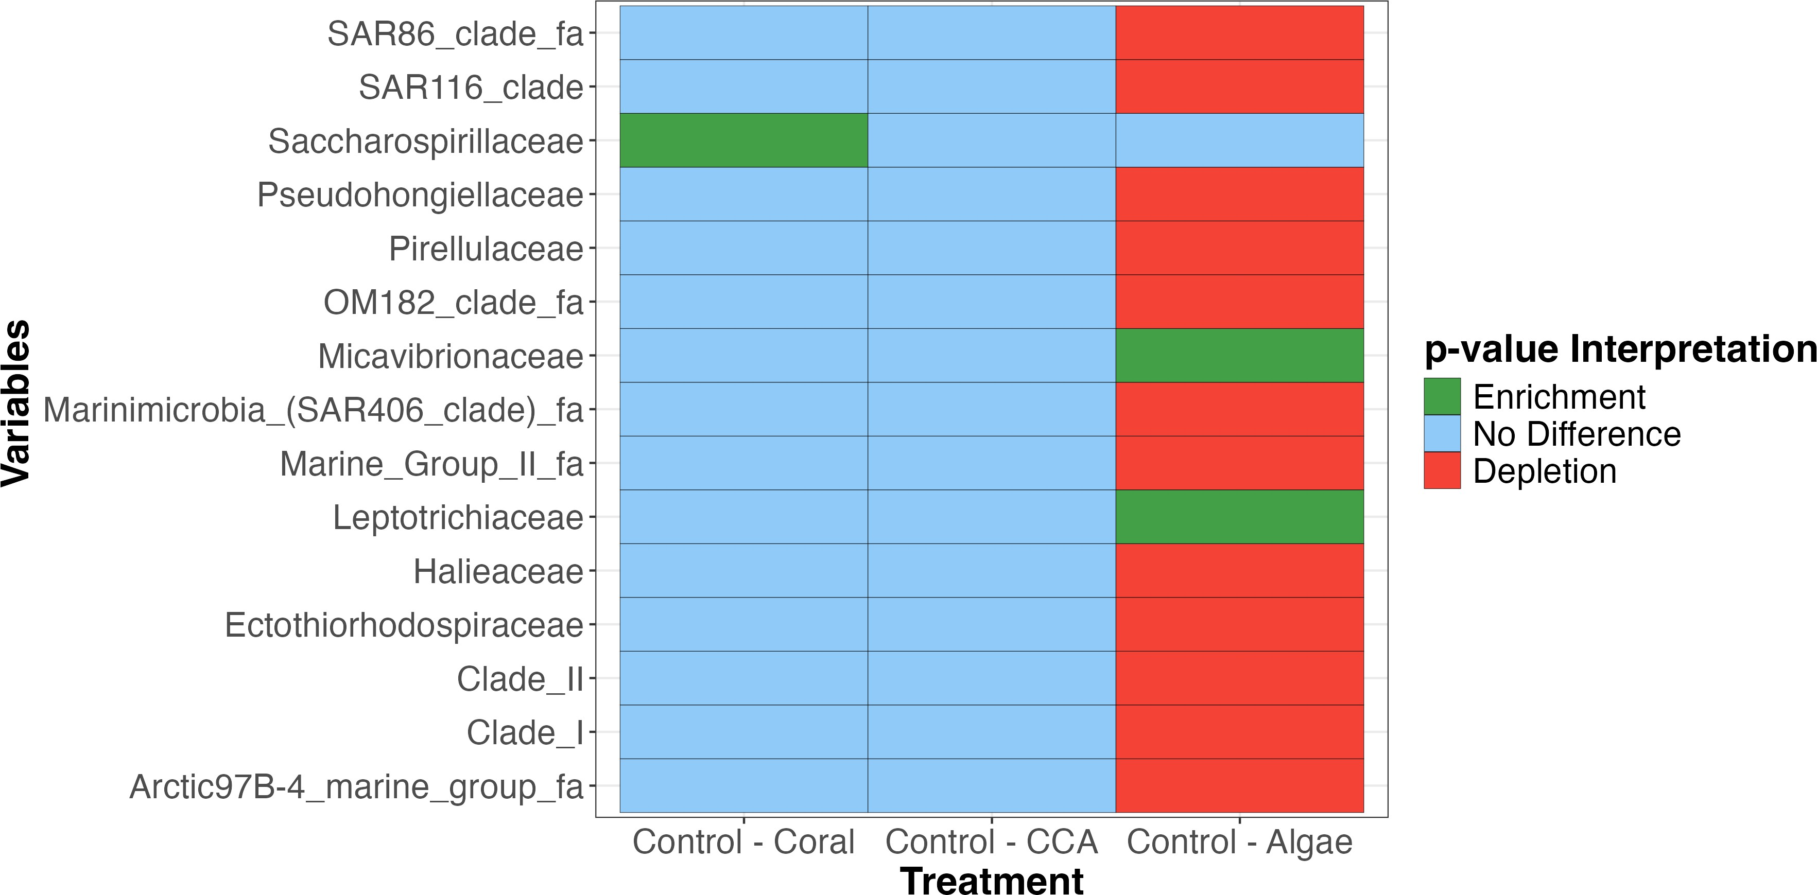

Figure 3.5: Heatmap showing significant differences in bacterial families across treatment. These microbial families had significant ANOVA results for treatment and time effects with no interactions between treatment effects and time effects. Specifically, 13 families were significantly depleted in algae communities compared to the controls and 1 family was enriched in algae communities compared to the controls and this pattern was independent of time.

Discussion

Benthic community composition drives treatment-associated patterns of organic exudation and bacterial community structure
Sampling time points significantly affected nutrient concentrations, but not organic exu-dation or bacterial abundance. Orthophosphate, nitrate, ammonia, and silica exhibited significant diel variations between 12:00 and 06:00 consistent with photosynthetic activity during daylight and respiration at night (Sawall and Hochberg 2018). Additionally, log₁₀-transformed flow rate did not significantly affect the treatment effects on relativized concentrations. As a result, observed patterns in organic exudations and bacteria abundance can be primarily attributable to changes in benthic community composition. Future experiments would benefit from automated flow regulation to further minimize flow-related sources of variability.

Organic exudation and composition are driven by benthic community assemblages
Results from our experiment have demonstrated that different mixed benthic communities do not significantly affect bulk DOC exudation but are rather linked to the exudation of compositionally distinct organic molecules, which are independent of sampling time point. Algae-enriched assemblages exhibited a preferential exudation of humic-like compounds which is consistent with Quinlan et al. (2018). However, unlike Quinlan et al. (2018), we did not observe an enrichment in proteinaceous fDOM in coral-associated treatments possibly due to microbial transformation of labile compounds before sampling (Tanaka et al., 2011). Although our results align with current literature, the scope of our methodologies lacks the resolution that targeted metabolomics provide in analyzing exudated organic compounds (Nelson et al. 2013; Quinlan et al. 2025; Wegley Kelly et al. 2021). Metabolomic surveys can provide invaluable insight on the interactions between benthic components such as allelopathy and chemical competition, especially during coral-algae competitive interaction, with implication on coral microbiome alteration, tissue degradation, and coral mortality (Barott et al. 2012; Morrow et al. 2012; Rasher and Hay 2010; Jennifer Smith et al. 2006). Additionally, limited sample size may have restricted the statistical power of the models and prevented the emergence of visible patterns.
Nevertheless, this study represents an initial step toward building controlled mixed community mesocosm models of tropical coral reefs. Results contribute to a mechanistic understanding of bentho-pelagic coupling and the onset of microbialization in tropical coral reefs. Our mesocosms represent a simplified subset of coral reef communities in Mo’orea and additional benthic constituents should be accounted for to establish a comprehensive profile of tropical reef exudation and their contribution to coral reef microbialization. Specifically, turf algae were identified as large contributors to the DOC exudation pool in mesocosm experiments and increase in abundance in degraded reef conditions (Haas et al. 2011; Mueller et al. 2022; Palmer, Rodríguez Esquivel, and Parker 2025).

Composition of organic exudates driven microbial community structure
Algae-dominated reefs exhibited elevated heterotrophic bacteria abundance and humic-like DOM exudation. Metabolomics surveys have shown visible differences in the composition of coral and macroalgal exometabolomes with macroalgae releasing DOM enriched in simple carbohydrates (Nelson et al. 2013; Wegley Kelly et al. 2022). Additionally, algal exudates were associated with greater microbial metabolic activity (oxygen demand) but less eﬀicient growth rate (carbon yield) in culture (Haas et al. 2011). Together, our results support the hypothesis of microbialization in degraded reef conditions. However, resolving the molecular classification of benthic exudates was outside of the scope of this project which limits our ability to resolve further interactions between organic exudates and microbial dynamics.
Microbial community structure associated with algae-enriched treatments has shifted over the 4 time points and was significantly different than the seawater control. This finding is consistent with previous incubation experiments where microbial communities showed significant differences based on their exposure to coral and algal exudates (Haas et al. 2011; Nelson et al. 2013). However, algae-enriched communities were depleted in oligotrophic families of bacteria, unlike previous studies which showed an enrichment in copiotrophic bacterial taxa in algal exudates (Haas et al. 2016). As such our results show that algal exudates restructure bacterial communities away from oligotrophic specialists. Algae-enriched communities were enriched in 2 bacterial families: Leptotrichiaceae, a facultative to obligate anaerobe (Eisenberg et al. 2018), and Micavibrionaceae. However, limited information could be found on these enriched families.

Conclusion
The preservation of coral reefs is an urgent conservation priority as corals have been steadily declining due to anthropogenic forcings and global climate change. Our findings show that macroalgal enrichment in coral reefs did not change the exudation of bulk DOC but rather altered the composition of organic exudates. Macroalgal enrichment is also associated with distinct bacterioplankton communities which are depleted of oligotrophic bacterial taxa. Developing a mechanistic understanding of coral-algal phase shifts and coral reef microbialization is essential to understand the resilience of coral reefs and their capacity to recover from disturbances, but also to identify coupled systems which may be impacted by biogeochemical changes, e.g., water quality, disease ecology, ecosystem productivity, and food web transfers. Insights from this study are particularly relevant for tropical coastal communities that rely on marine resources for sustenance, cultural practices, and economic development. Understanding the intricacy of microbially mediated processes is an important consideration for the development of management plans at the local level but also for regional and global conservation efforts. Further investigations on the composition of the benthic exudates and the bacterial metabolic pathways involved in the degradation of exudates are necessary to better understand biogeochemical cycling under coral-algal phase shifts worldwide.

References
Adam, Thomas C., Deron E. Burkepile, Sally J. Holbrook, Robert C. Carpenter, Joachim Claudet, Charles Loiseau, Lauric Thiault, Andrew J. Brooks, Libe Washburn, and Rus-sell J. Schmitt. 2021. “Landscape-Scale Patterns of Nutrient Enrichment in a Coral Reef Ecosystem: Implications for Coral to Algae Phase Shifts.” Ecological Applications 31 (1): e2227. https://doi.org/10.1002/eap.2227.
Arisdakessian, Cédric, Sean B. Cleveland, and Mahdi Belcaid. 2020. “PEARC ’20: Practice and Experience in Advanced Research Computing.” In, 120–24. Portland OR USA: ACM. https://doi.org/10.1145/3311790.3396664.
Bahr, Keisha D., Paul L. Jokiel, and Robert J. Toonen. 2015. “The Unnatural History of Kāne‘ohe Bay: Coral Reef Resilience in the Face of Centuries of Anthropogenic Impacts.” PeerJ 3 (May): e950. https://doi.org/10.7717/peerj.950.
Barott, Kl, Gj Williams, Mja Vermeij, J Harris, Je Smith, Fl Rohwer, and Sa Sandin. 2012. “Natural History of Coral-Algae Competition Across a Gradient of Human Activity in the Line Islands.” Marine Ecology Progress Series 460 (July): 1–12. https://doi.org/10. 3354/meps09874.
Brocke, Hannah J., Frank Wenzhoefer, Dirk De Beer, Benjamin Mueller, Fleur C. Van Duyl, and Maggy M. Nugues. 2015. “High Dissolved Organic Carbon Release by Benthic Cyanobacterial Mats in a Caribbean Reef Ecosystem.” Scientific Reports 5 (1): 8852. https://doi.org/10.1038/srep08852.
Bruno, John F., and Elizabeth R. Selig. 2007. “Regional Decline of Coral Cover in the Indo-Pacific: Timing, Extent, and Subregional Comparisons.” Edited by Rob Freckleton. PLoS ONE 2 (8): e711. https://doi.org/10.1371/journal.pone.0000711.
Burkepile, Deron E., and Mark E. Hay. 2006. “Herbivore Vs. Nutrient Control of Marine Primary Producers: Context-Dependent Effects.” Ecology 87 (12): 3128–39. https:
//doi.org/10.1890/0012-9658(2006)87%5B3128:HVNCOM%5D2.0.CO;2.
Callahan, Benjamin J, Paul J McMurdie, Michael J Rosen, Andrew W Han, Amy Jo A Johnson, and Susan P Holmes. 2016. “DADA2: High Resolution Sample Inference from Illumina Amplicon Data.” Nature Methods 13 (7): 581–83. https://doi.org/10.1038/ nmeth.3869.
Caporaso, J. Greg, Gail Ackermann, Amy Apprill, Markus Bauer, Donna Berg-Lyons, Jason Betley, Noah Fierer, et al. 2018. “EMP 16S Illumina Amplicon Protocol V.1,” April. https://www.protocols.io/view/emp-16s-illumina-amplicon-protocol-kqdg3dzzl25z/v1.
Carlson, Craig A., Dennis A. Hansell, Norman B. Nelson, David A. Siegel, William M. Sme-thie, Samar Khatiwala, Meredith M. Meyers, and Elisa Halewood. 2010. “Dissolved

Organic Carbon Export and Subsequent Remineralization in the Mesopelagic and Bathy-pelagic Realms of the North Atlantic Basin.” Deep Sea Research Part II: Topical Studies in Oceanography 57 (16): 1433–45. https://doi.org/10.1016/j.dsr2.2010.02.013.
Cleveland, Sean, Cedric Arisdakessian, Craig Nelson, Mahdi Belcaid, Kiana Frank, and Gwen Jacobs. 2022. “PEARC ’22: Practice and Experience in Advanced Research Com-puting.” In, 1–7. Boston MA USA: ACM. https://doi.org/10.1145/3491418.3530291.
Coble, Paula G. 1996. “Characterization of Marine and Terrestrial DOM in Seawater Using Excitation-Emission Matrix Spectroscopy.” Marine Chemistry 51 (4): 325–46. https:
//doi.org/10.1016/0304-4203(95)00062-3.
Comstock, Jacqueline, Craig E. Nelson, Anna James, Emma Wear, Nicholas Baetge, Kristina Remple, Amethyst Juknavorian, and Craig A. Carlson. 2022. “Bacterioplank-ton Communities Reveal Horizontal and Vertical Influence of an Island Mass Effect.” En-vironmental Microbiology 24 (9): 4193–4208. https://doi.org/10.1111/1462-2920.16092. Done, T. J. 1992. “Phase Shifts in Coral Reef Communities and Their Ecological Signifi-
cance.”
Edmunds, P. J., C. John, J. J. Leichter, C. Moritz, K. C. Scafidi, K. E. Speare, G. Sred-nick, and A. S. J. Wyatt. 2025. “Long-Term Community Dynamics Are Heterogeneous Between Fringing- and Fore-Reef Habitats on an Indo-Pacific Coral Reef.” Ecosphere 16 (10): e70398. https://doi.org/10.1002/ecs2.70398.
Eisenberg, Tobias, Stefanie P. Glaeser, Jochen Blom, and Peter Kämpfer. 2018. “Lep-totrichiaceae.” In, 1–9. John Wiley & Sons, Ltd. https://doi.org/https://doi-org.eres. library.manoa.hawaii.edu/10.1002/9781118960608.fbm00155.pub2.
Frøslev, Tobias Guldberg, Rasmus Kjøller, Hans Henrik Bruun, Rasmus Ejrnæs, Ane Kirs-tine Brunbjerg, Carlotta Pietroni, and Anders Johannes Hansen. 2017. “Algorithm for Post-Clustering Curation of DNA Amplicon Data Yields Reliable Biodiversity Es-timates.” Nature Communications 8 (1): 1188. https://doi.org/10.1038/s41467-017-01312-x.
Haas, Andreas F., Mohamed F. M. Fairoz, Linda W. Kelly, Craig E. Nelson, Elizabeth A. Dinsdale, Robert A. Edwards, Steve Giles, et al. 2016. “Global Microbialization of Coral Reefs.” Nature Microbiology 1 (6): 16042. https://doi.org/10.1038/nmicrobiol.2016.42.
Haas, Andreas F., Craig E. Nelson, Forest Rohwer, Linda Wegley-Kelly, Steven D. Quistad, Craig A. Carlson, James J. Leichter, Mark Hatay, and Jennifer E. Smith. 2013. “Influ-ence of Coral and Algal Exudates on Microbially Mediated Reef Metabolism.” PeerJ 1 (July): e108. https://doi.org/10.7717/peerj.108.
Haas, Andreas F., Craig E. Nelson, Linda Wegley Kelly, Craig A. Carlson, Forest Rohwer, James J. Leichter, Alex Wyatt, and Jennifer E. Smith. 2011. “Effects of Coral Reef Ben-thic Primary Producers on Dissolved Organic Carbon and Microbial Activity.” Edited by Richard K. F. Unsworth. PLoS ONE 6 (11): e27973. https://doi.org/10.1371/journal. pone.0027973.
Hughes, Terence P. 1994. “Catastrophes, Phase Shifts, and Large-Scale Degradation of a Caribbean Coral Reef.” Science 265 (5178): 1547–51. https://www.jstor.org/stable/
2884556.
Huguet, A., L. Vacher, S. Relexans, S. Saubusse, J. M. Froidefond, and E. Parlanti. 2009. “Properties of Fluorescent Dissolved Organic Matter in the Gironde Estuary.” Organic Geochemistry 40 (6): 706–19. https://doi.org/10.1016/j.orggeochem.2009.03.002.

Jani, Andrea J, Jessie Bushell, Cédric G Arisdakessian, Mahdi Belcaid, Daniel M Boiano, Cathy Brown, and Roland A Knapp. 2021. “The Amphibian Microbiome Exhibits Poor Resilience Following Pathogen-Induced Disturbance.” The ISME Journal 15 (6): 1628–40. https://doi.org/10.1038/s41396-020-00875-w.
John, Christian, Nyssa J. Silbiger, Thomas C. Adam, Danielle M. Barnas, Kalia S. Bis-tolas, Robert C. Carpenter, Noe Castañeda, et al. 2025. “Terrigenous Inputs Link Nutrient Dynamics to Microbial Communities in a Tropical Lagoon.” Limnology and Oceanography 70 (12): 3741–54. https://doi.org/10.1002/lno.70240.
Jones, Ross, Rebecca Fisher, and Pia Bessell-Browne. 2019. “Sediment Deposition and Coral Smothering.” Edited by Judi Hewitt. PLOS ONE 14 (6): e0216248. https:
//doi.org/10.1371/journal.pone.0216248.
Kayal, Mohsen, Julie Vercelloni, Thierry Lison De Loma, Pauline Bosserelle, Yannick Chancerelle, Sylvie Geoffroy, Céline Stievenart, et al. 2012. “Predator Crown-of-Thorns Starfish (Acanthaster Planci) Outbreak, Mass Mortality of Corals, and Cascading Ef-fects on Reef Fish and Benthic Communities.” Edited by Christopher Fulton. PLoS ONE 7 (10): e47363. https://doi.org/10.1371/journal.pone.0047363.
Kealoha, Andrea, Paulo H. R. Calil, Nicholas James Hawco, Gregory Masessa, Joelle Mattos, Eileen Nalley, Craig E. Nelson, et al. 2025. “Water Quality Parameters from Discrete Shoreline and Transect Sampling in West Maui (Lahaina Area), Hawai i, Following the Lahaina Wildfires, Aug 2023 to Oct 2024,” October. https://hdl.handle.net/1912/ 72314.
Kothawala, Dolly N., Kathleen R. Murphy, Colin A. Stedmon, Gesa A. Weyhenmeyer, and Lars J. Tranvik. 2013. “Inner Filter Correction of Dissolved Organic Matter Fluores-cence.” Limnology and Oceanography: Methods 11 (12): 616–30. https://doi.org/10. 4319/lom.2013.11.616.
Lawaetz, Anders, and Colin Stedmon. 2009. “Fluorescence Intensity Calibration Using the Raman Scatter Peak of Water.” Applied Spectroscopy 63 (September): 936–40. https:
//doi.org/10.1366/000370209788964548.
Leichter, James, Alice Alldredge, Giacomo Bernardi, Andrew Brooks, Craig Carlson, Robert Carpenter, Peter Edmunds, et al. 2013. “Biological and Physical Interactions on a Trop-ical Island Coral Reef: Transport and Retention Processes on Moorea, French Polynesia.” Oceanography 26 (3): 52–63. https://doi.org/10.5670/oceanog.2013.45.
Lesser, Michael P. 2021. “Eutrophication on Coral Reefs: What Is the Evidence for Phase Shifts, Nutrient Limitation and Coral Bleaching.” BioScience 71 (12): 1216–33. https:
//doi.org/10.1093/biosci/biab101.
McCook, L. J. 1999. “Macroalgae, Nutrients and Phase Shifts on Coral Reefs: Scientific Issues and Management Consequences for the Great Barrier Reef.” Coral Reefs 18 (4): 357–67. https://doi.org/10.1007/s003380050213.
McKnight, Diane M., Elizabeth W. Boyer, Paul K. Westerhoff, Peter T. Doran, Thomas Kulbe, and Dale T. Andersen. 2001. “Spectrofluorometric Characterization of Dis-solved Organic Matter for Indication of Precursor Organic Material and Aromaticity.” Limnology and Oceanography 46 (1): 38–48. https://doi.org/10.4319/lo.2001.46.1.0038. Morrow, Kathleen M., Raphael Ritson-Williams, Cliff Ross, Mark R. Liles, and Valerie J. Paul. 2012. “Macroalgal Extracts Induce Bacterial Assemblage Shifts and Sublethal Tissue Stress in Caribbean Corals.” Edited by Vishal Shah. PLoS ONE 7 (9): e44859.

https://doi.org/10.1371/journal.pone.0044859.
Mueller, Benjamin, Hannah J. Brocke, Forest L. Rohwer, Thorsten Dittmar, Jef Huisman, Mark J. A. Vermeij, and Jasper M. de Goeij. 2022. “Nocturnal Dissolved Organic Matter Release by Turf Algae and Its Role in the Microbialization of Reefs.” Functional Ecology 36 (8): 2104–18. https://doi.org/10.1111/1365-2435.14101.
Nelson, Craig E, Alice L Alldredge, Elizabeth A McCliment, Linda A Amaral-Zettler, and Craig A Carlson. 2011. “Depleted Dissolved Organic Carbon and Distinct Bacterial Communities in the Water Column of a Rapid-Flushing Coral Reef Ecosystem.” The ISME Journal 5 (8): 1374–87. https://doi.org/10.1038/ismej.2011.12.
Nelson, Craig E., Megan J. Donahue, Henrieta Dulaiova, Stuart J. Goldberg, Florybeth F. La Valle, Katie Lubarsky, Justin Miyano, Christina Richardson, Nyssa J. Silbiger, and Florence I. M. Thomas. 2015. “Fluorescent Dissolved Organic Matter as a Multivariate Biogeochemical Tracer of Submarine Groundwater Discharge in Coral Reef Ecosystems.” Marine Chemistry 177 (December): 232–43. https://doi.org/10.1016/j.marchem.2015.
06.026.
Nelson, Craig E, Stuart J Goldberg, Linda Wegley Kelly, Andreas F Haas, Jennifer E Smith, Forest Rohwer, and Craig A Carlson. 2013. “Coral and Macroalgal Exudates Vary in Neutral Sugar Composition and Differentially Enrich Reef Bacterioplankton Lineages.” The ISME Journal 7 (5): 962–79. https://doi.org/10.1038/ismej.2012.161.
Nelson, Craig E., Linda Wegley Kelly, and Andreas F. Haas. 2023. “Microbial Interactions with Dissolved Organic Matter Are Central to Coral Reef Ecosystem Function and Resilience.” Annual Review of Marine Science 15 (1): 431–60. https://doi.org/10.1146/ annurev-marine-042121-080917.
Oksanen, Jari, Gavin L. Simpson, F. Guillaume Blanchet, Roeland Kindt, Pierre Legendre, Peter R. Minchin, R. B. O’Hara, et al. 2026. Vegan: Community Ecology Package. https://cran.r-project.org/web/packages/vegan/index.html.
Palmer, Caroline V., Shanttal Valeria Rodríguez Esquivel, and Christopher M. Parker. 2025. “El Niño-Driven Phase Shift to Algal Dominance on Isla Del Caño’s Coral Reefs: Implications for Urgent Restoration.” PeerJ 13 (November): e20088. https:
//doi.org/10.7717/peerj.20088.
Pedersen, Thomas Lin. 2025. “Patchwork: The Composer of Plots.” https://doi.org/10.
32614/CRAN.package.patchwork.
Quinlan, Zachary A., Craig E. Nelson, Irina Koester, Daniel Petras, Louis-Felix Noth-ias, Jacqueline Comstock, Brandie M. White, et al. 2025. “Microbial Community Metabolism of Coral Reef Exometabolomes Broadens the Chemodiversity of Labile Dis-solved Organic Matter.” Environmental Microbiology 27 (3): e70064. https://doi.org/ 10.1111/1462-2920.70064.
Quinlan, Zachary A., Kristina Remple, Michael D. Fox, Nyssa J. Silbiger, Thomas A. Oliver, Hollie M. Putnam, Linda Wegley Kelly, Craig A. Carlson, Megan J. Donahue, and Craig
E. Nelson. 2018. “Fluorescent Organic Exudates of Corals and Algae in Tropical Reefs Are Compositionally Distinct and Increase with Nutrient Enrichment.” Limnology and Oceanography Letters 3 (4): 331–40. https://doi.org/10.1002/lol2.10074.
Rasher, Douglas B., and Mark E. Hay. 2010. “Chemically Rich Seaweeds Poison Corals When Not Controlled by Herbivores.” Proceedings of the National Academy of Sciences 107 (21): 9683–88. https://doi.org/10.1073/pnas.0912095107.

Rognes, Torbjørn, Tomáš Flouri, Ben Nichols, Christopher Quince, and Frédéric Mahé. 2016. “VSEARCH: A Versatile Open Source Tool for Metagenomics.” PeerJ 4 (October): e2584. https://doi.org/10.7717/peerj.2584.
Sawall, Yvonne, and Eric J. Hochberg. 2018. “Diel Versus Time-Integrated (Daily) Pho-tosynthesis and Irradiance Relationships of Coral Reef Organisms and Communities.” Edited by Cristina Linares. PLOS ONE 13 (12): e0208607. https://doi.org/10.1371/ journal.pone.0208607.
Schloss, Patrick D., Sarah L. Westcott, Thomas Ryabin, Justine R. Hall, Martin Hartmann, Emily B. Hollister, Ryan A. Lesniewski, et al. 2009. “Introducing Mothur: Open-Source, Platform-Independent, Community-Supported Software for Describing and Comparing Microbial Communities.” Applied and Environmental Microbiology 75 (23): 7537–41. https://doi.org/10.1128/AEM.01541-09.
Schmitt, Russell J., Sally J. Holbrook, Samantha L. Davis, Andrew J. Brooks, and Thomas
C. Adam. 2019. “Experimental Support for Alternative Attractors on Coral Reefs.” Proceedings of the National Academy of Sciences 116 (10): 4372–81. https://doi.org/10. 1073/pnas.1812412116.
Selph, Karen E. 2021. “Enumeration of Marine Microbial Organisms by Flow Cytometry Using Near-UV Excitation of Hoechst 34580-Stained DNA.” Limnology and Oceanogra-phy: Methods 19 (10): 692–701. https://doi.org/10.1002/lom3.10454.
Silveira, Cynthia B., Arthur W. Silva-Lima, Ronaldo B. Francini-Filho, Jomar S. M. Mar-ques, Marcelo G. Almeida, Cristiane C. Thompson, Carlos E. Rezende, et al. 2015. “Mi-crobial and Sponge Loops Modify Fish Production in Phase-Shifting Coral Reefs.” En-vironmental Microbiology 17 (10): 3832–46. https://doi.org/10.1111/1462-2920.12851.
Smith, Jennifer, Morrigan Shaw, Rob Edwards, David Obura, Olga Pantos, Enric Sala, Stuart Sandin, Steven Smriga, Mark Hatay, and Forest Rohwer. 2006. “Indirect Effects of Algae on Coral: Algae-Mediated, Microbe-Induced Coral Mortality.” Ecology Letters 9 (August): 835–45. https://doi.org/10.1111/j.1461-0248.2006.00937.x.
Smith, J., C. Smith, and C. Hunter. 2001. “An Experimental Analysis of the Effects of Herbivory and Nutrient Enrichment on Benthic Community Dynamics on a Hawaiian Reef.” Coral Reefs 19 (4): 332–42. https://doi.org/10.1007/s003380000124.
Sparagon, Wesley J., Milou G. I. Arts, Zachary A. Quinlan, Linda Wegley Kelly, Irina Koester, Jacqueline Comstock, Jessica A. Bullington, et al. 2024. “Coral Thermal Stress and Bleaching Enrich and Restructure Reef Microbial Communities via Altered Organic Matter Exudation.” Communications Biology 7 (1): 160. https://doi.org/10. 1038/s42003-023-05730-0.
Tanaka, Y., H. Ogawa, and T. Miyajima. 2011. “Bacterial Decomposition of Coral Mucus as Evaluated by Long-Term and Quantitative Observation.” Coral Reefs 30 (2): 443–49. https://doi.org/10.1007/s00338-011-0729-3.
Walters, William, Embriette R. Hyde, Donna Berg-Lyons, Gail Ackermann, Greg Humphrey, Alma Parada, Jack A. Gilbert, et al. 2016. “Improved Bacterial 16S rRNA Gene (V4 and V4-5) and Fungal Internal Transcribed Spacer Marker Gene Primers for Microbial Community Surveys.” Edited by Holly Bik. mSystems 1 (1): e00009–15. https://doi. org/10.1128/mSystems.00009-15.
Wang, Qiong, George M. Garrity, James M. Tiedje, and James R. Cole. 2007. “Naïve Bayesian Classifier for Rapid Assignment of rRNA Sequences into the New Bacterial

Taxonomy.” Applied and Environmental Microbiology 73 (16): 5261–67. https://doi. org/10.1128/AEM.00062-07.
Wegley Kelly, Linda, Craig E. Nelson, Lihini I. Aluwihare, Milou G. I. Arts, Pieter C. Dorrestein, Irina Koester, Shayle B. Matsuda, Daniel Petras, Zachary A. Quinlan, and Andreas F. Haas. 2021. “Molecular Commerce on Coral Reefs: Using Metabolomics to Reveal Biochemical Exchanges Underlying Holobiont Biology and the Ecology of Coastal Ecosystems.” Frontiers in Marine Science 8 (July): 630799. https://doi.org/10.3389/ fmars.2021.630799.
Wegley Kelly, Linda, Craig E. Nelson, Daniel Petras, Irina Koester, Zachary A. Quin-lan, Milou G. I. Arts, Louis-Felix Nothias, et al. 2022. “Distinguishing the Molecular Diversity, Nutrient Content, and Energetic Potential of Exometabolomes Produced by Macroalgae and Reef-Building Corals.” Proceedings of the National Academy of Sciences 119 (5): e2110283119. https://doi.org/10.1073/pnas.2110283119.
Wickham, Hadley. 2016. Ggplot2: Elegant Graphics for Data Analysis. Springer-Verlag New York. https://ggplot2.tidyverse.org.
Wild, C, W Niggl, Ms Naumann, and Af Haas. 2010. “Organic Matter Release by Red Sea Coral Reef Organisms—potential Effects on Microbial Activity and in Situ O2 Avail-ability.” Marine Ecology Progress Series 411 (July): 61–71. https://doi.org/10.3354/ meps08653.
Yilmaz, Pelin, Laura Wegener Parfrey, Pablo Yarza, Jan Gerken, Elmar Pruesse, Christian Quast, Timmy Schweer, Jörg Peplies, Wolfgang Ludwig, and Frank Oliver Glöckner. 2014. “The SILVA and “All-Species Living Tree Project (LTP)” Taxonomic Frameworks.” Nucleic Acids Research 42 (D1): D643–48. https://doi.org/10.1093/nar/gkt1209.

Supplemental Material
  - Simple Linear Regression between Nutrients, Chlorophyll-a and Organic Matter vs. Flow Rate

Summary of Treatment, Time and Treatment-Time Interaction on Nutrient Measurements

Summary of Treatment, Time and Treatment-Time Interaction on Bacterial Families Relative Abundance

Table 6.1: Results of the Simple Linear Regressions between Nutrients and Chlorophyll-a vs. Flow Rate
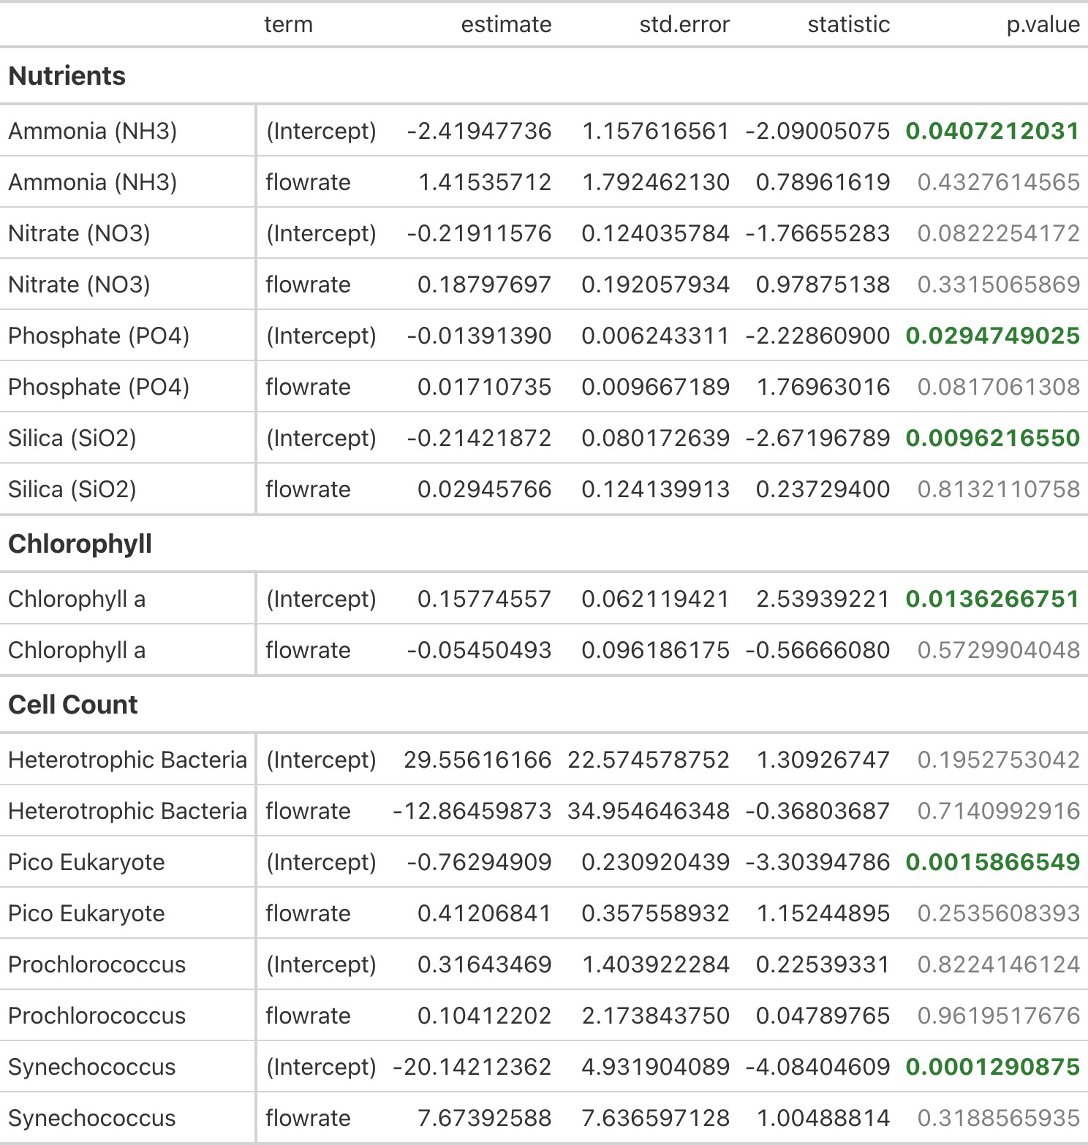

Table 6.2: Results of the Simple Linear Regressions between DOC and fDOM Indices vs. Flow Rate
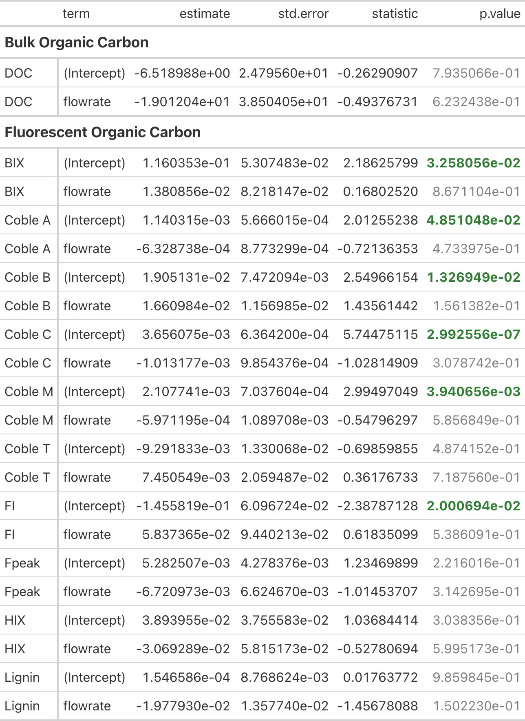

Table 6.3: ANOVA Results of the Nutrients Linear Mixed Effects Models
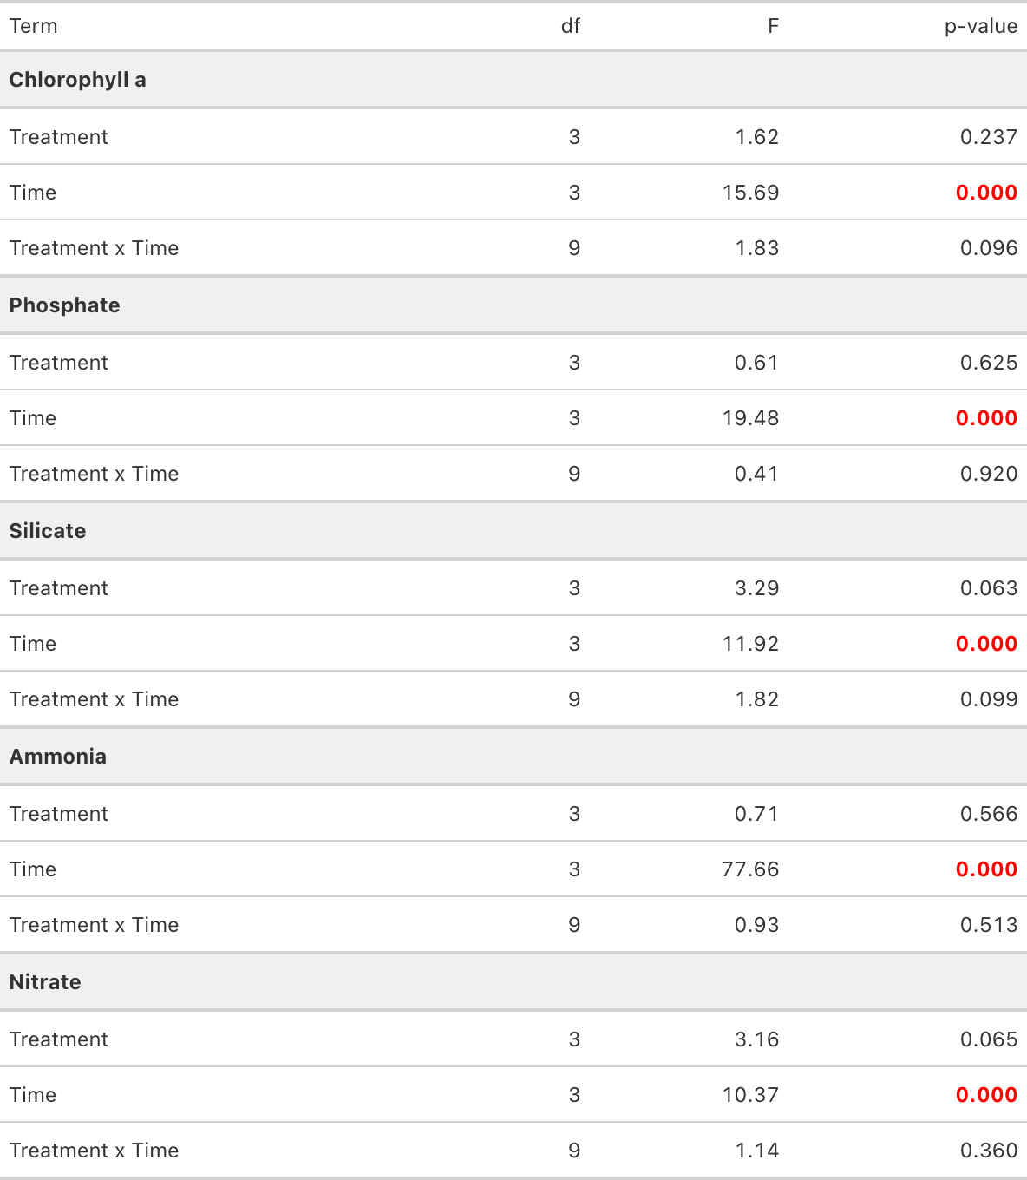

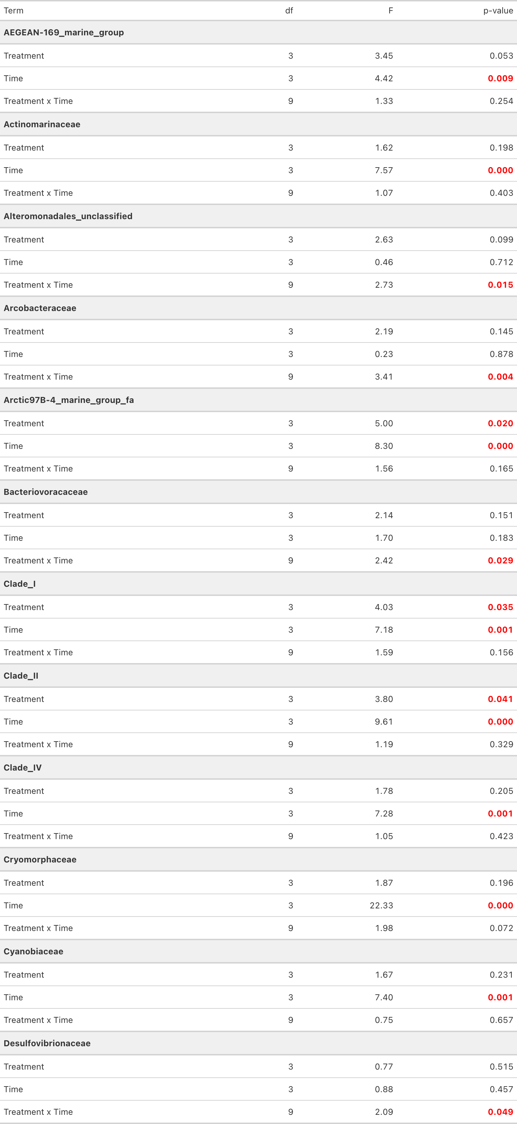
Table 6.4: ANOVA Results of the Bacteria Families Linear Mixed Effects Models (A)

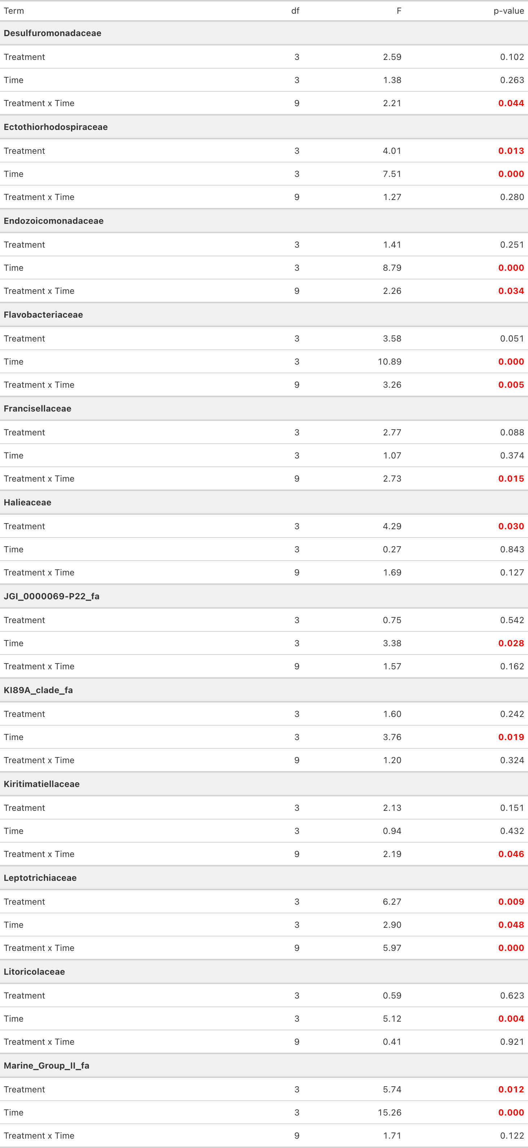
Table 6.5: ANOVA Results of the Bacteria Families Linear Mixed Effects Models (B)

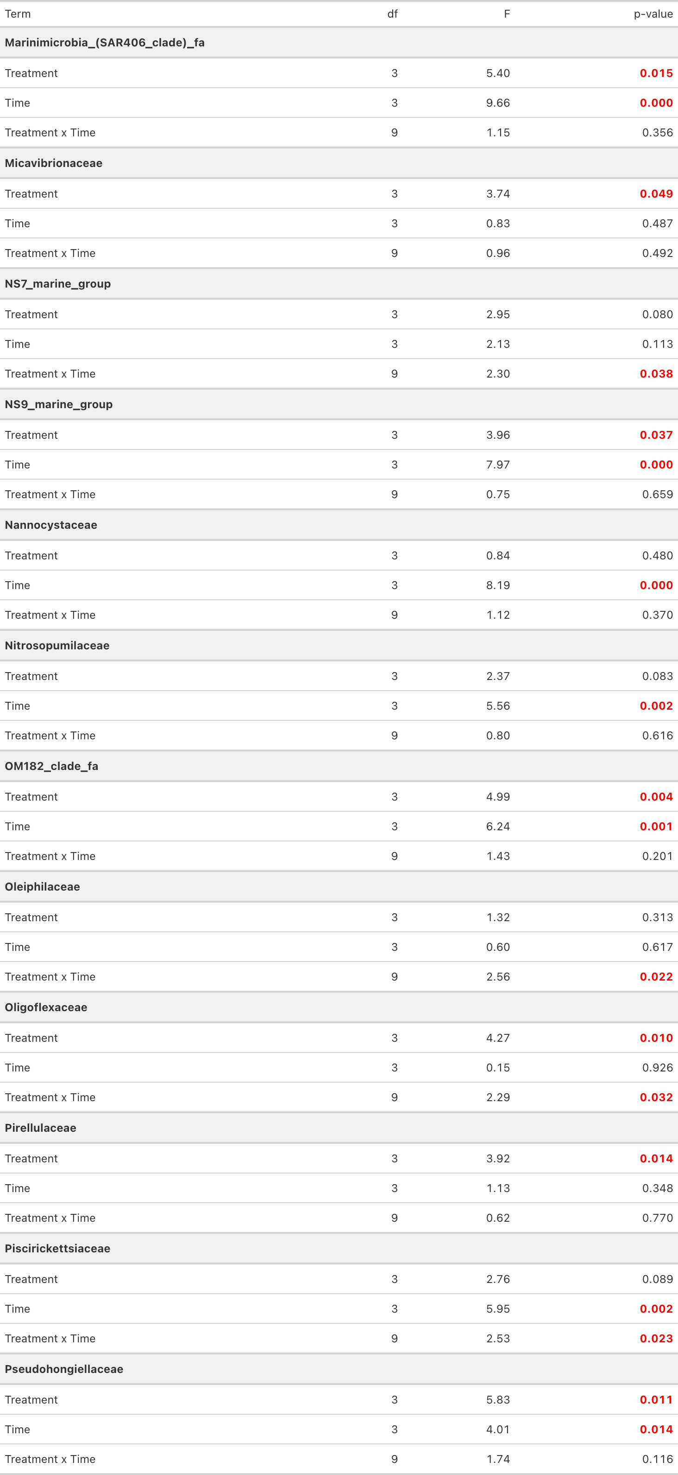
Table 6.6: ANOVA Results of the Bacteria Families Linear Mixed Effects Models (C)

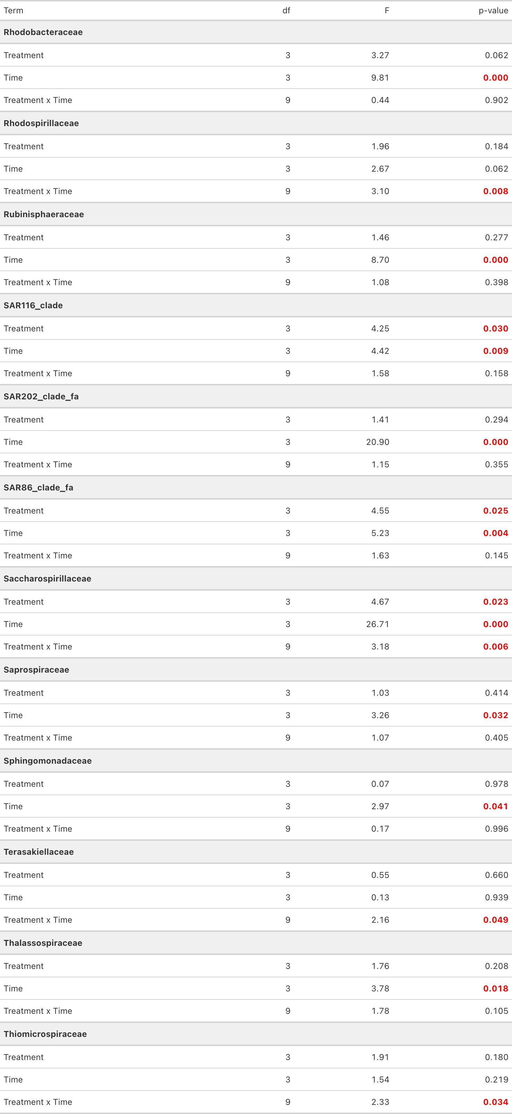
Table 6.7: ANOVA Results of the Bacteria Families Linear Mixed Effects Models (D)

